






Prepare chocolate and produce chocolate products
D1.HCC.CL2.13
D1.HPA.CL4.05
Trainer Guide

Prepare chocolate and produce chocolate products

D1.HCC.CL2.13
D1.HPA.CL4.05

Trainer Guide




Project Base
William Angliss Institute of TAFE
555 La Trobe Street
Melbourne 3000 Victoria
Telephone: | (03) 9606 2111
Facsimile: | (03) 9670 1330
Acknowledgements
Project Director: | Wayne Crosbie
Chief Writer: | Alan Hickman
Subject Writer: | Garry Blackburn
Project Manager: | Alan Maguire
Editor: | Jim Irwin
DTP/Production: | Daniel Chee, Mai Vu, Kaly Quach

The Association of Southeast Asian Nations (ASEAN) was established on 8 August 1967. The Member States of the Association are Brunei Darussalam, Cambodia, Indonesia, Lao PDR, Malaysia, Myanmar, Philippines, Singapore, Thailand and Viet Nam.
The ASEAN Secretariat is based in Jakarta, Indonesia.
General Information on ASEAN appears online at the ASEAN Website: www.asean.org.
All text is produced by William Angliss Institute of TAFE for the ASEAN Project on “Toolbox Development for Front Office, Food and Beverage Services and Food Production Divisions”.
This publication is supported by the Australian Government’s aid program through the ASEAN-Australia Development Cooperation Program Phase II (AADCP II).
Copyright: Association of Southeast Asian Nations (ASEAN) 2013.
All rights reserved.
Disclaimer
Every effort has been made to ensure that this publication is free from errors or omissions. However, you should conduct your own enquiries and seek professional advice before relying on any fact, statement or matter contained in this book. The ASEAN Secretariat and William Angliss Institute of TAFE are not responsible for any injury, loss or damage as a result of material included or omitted from this course. Information in this module is current at the time of publication. Time of publication is indicated in the date stamp at the bottom of each page.
Some images appearing in this resource have been purchased from stock photography suppliers Shutterstock and iStockphoto and other third party copyright owners and as such are non-transferable and non-exclusive. Clip arts, font images and illustrations used are from the Microsoft Office Clip Art and Media Library. Some images have been provided by and are the property of William Angliss Institute.
Additional images have been sourced from Flickr and SKC and are used under Creative Commons licence: http://creativecommons.org/licenses/by/2.0/deed.en
File name: TG_Prepare_choc_&_produce_choc_products_FN_060214





Table of Contents
Competency Based Training (CBT) and assessment - An introduction for trainers 1
Competency standard 11
Notes and PowerPoint slides 21
Recommended training equipment 49
Instructions for Trainers for using PowerPoint – Presenter View 51
Appendix – ASEAN acronyms 53

Competency Based Training (CBT) and assessment - An introduction for trainers

Competency
Competency refers to the ability to perform particular tasks and duties to the standard of performance expected in the workplace.
Competency requires the application of specified knowledge, skills and attitudes relevant to effective participation, consistently over time and in the workplace environment.
The essential skills and knowledge are either identified separately or combined.
Knowledge identifies what a person needs to know to perform the work in an informed and effective manner.
Skills describe the application of knowledge to situations where understanding is converted into a workplace outcome.
Attitude describes the founding reasons behind the need for certain knowledge or why skills are performed in a specified manner.
Competency covers all aspects of workplace performance and involves:
- Performing individual tasks
- Managing a range of different tasks
- Responding to contingencies or breakdowns
- Dealing with the responsibilities of the workplace
- Working with others.

Unit of Competency
Like with any training qualification or program, a range of subject topics are identified that focus on the ability in a certain work area, responsibility or function.
Each manual focuses on a specific unit of competency that applies in the hospitality workplace.
In this manual a unit of competency is identified as a ‘unit’.
Each unit of competency identifies a discrete workplace requirement and includes:
- Knowledge and skills that underpin competency
- Language, literacy and numeracy
- Occupational health and safety requirements.
Each unit of competency must be adhered to in training and assessment to ensure consistency of outcomes.

Element of Competency
An element of competency describes the essential outcomes within a unit of competency.
The elements of competency are the basic building blocks of the unit of competency. They describe in terms of outcomes the significant functions and tasks that make up the competency.
In this manual elements of competency are identified as an ‘element’.

Performance criteria
Performance criteria indicate the standard of performance that is required to demonstrate achievement within an element of competency. The standards reflect identified industry skill needs.
Performance criteria will be made up of certain specified skills, knowledge and attitudes.

Learning
For the purpose of this manual learning incorporates two key activities:
- Training
- Assessment.
Both of these activities will be discussed in detail in this introduction.
Today training and assessment can be delivered in a variety of ways. It may be provided to participants:
- On-the-job – in the workplace
- Off-the-job – at an educational institution or dedicated training environment
- As a combination of these two options.
No longer is it necessary for learners to be absent from the workplace for long periods of time in order to obtain recognised and accredited qualifications.

Learning Approaches
This manual will identify two avenues to facilitate learning:
Competency Based Training (CBT)
This is the strategy of developing a participant’s competency.
Educational institutions utilise a range of training strategies to ensure that participants are able to gain the knowledge and skills required for successful:
- Completion of the training program or qualification
- Implementation in the workplace.
The strategies selected should be chosen based on suitability and the learning styles of participants.

Competency Based Assessment (CBA)
This is the strategy of assessing competency of a participant.
Educational institutions utilise a range of assessment strategies to ensure that participants are assessed in a manner that demonstrates validity, fairness, reliability, flexibility and fairness of assessment processes.

Flexibility in Learning
It is important to note that flexibility in training and assessment strategies is required to meet the needs of participants who may have learning difficulties. The strategies used will vary, taking into account the needs of individual participants with learning difficulties. However they will be applied in a manner which does not discriminate against the participant or the participant body as a whole.
Catering for Participant Diversity
Participants have diverse backgrounds, needs and interests. When planning training and assessment activities to cater for individual differences, trainers and assessors should:
- Consider individuals’ experiences, learning styles and interests
- Develop questions and activities that are aimed at different levels of ability
- Modify the expectations for some participants
- Provide opportunities for a variety of forms of participation, such as individual, pair and small group activities
- Assess participants based on individual progress and outcomes.
The diversity among participants also provides a good reason for building up a learning community in which participants support each other’s learning.
Participant Centred Learning
This involves taking into account structuring training and assessment that:
- Builds on strengths – Training environments need to demonstrate the many positive features of local participants (such as the attribution of academic success to effort, and the social nature of achievement motivation) and of their trainers (such as a strong emphasis on subject disciplines and moral responsibility). These strengths and uniqueness of local participants and trainers should be acknowledged and treasured
- Acknowledges prior knowledge and experience – The learning activities should be planned with participants’ prior knowledge and experience in mind
- Understands learning objectives – Each learning activity should have clear learning objectives and participants should be informed of them at the outset. Trainers should also be clear about the purpose of assignments and explain their significance to participants
- Teaches for understanding – The pedagogies chosen should aim at enabling participants to act and think flexibly with what they know
- Teaches for independent learning – Generic skills and reflection should be nurtured through learning activities in appropriate contexts of the curriculum. Participants should be encouraged to take responsibility for their own learning
- Enhances motivation – Learning is most effective when participants are motivated. Various strategies should be used to arouse the interest of participants
- Makes effective use of resources – A variety of teaching resources can be employed as tools for learning
- Maximises engagement – In conducting learning activities, it is important for the minds of participants to be actively engaged
- Aligns assessment with learning and teaching – Feedback and assessment should be an integral part of learning and teaching
- Caters for learner diversity – Trainers should be aware that participants have different characteristics and strengths and try to nurture these rather than impose a standard set of expectations.
Active Learning
The goal of nurturing independent learning in participants does not imply that they always have to work in isolation or solely in a classroom. On the contrary, the construction of knowledge in tourism and hospitality studies can often best be carried out in collaboration with others in the field. Sharing experiences, insights and views on issues of common concern, and working together to collect information through conducting investigative studies in the field (active learning) can contribute a lot to their eventual success.
Active learning has an important part to play in fostering a sense of community in the class. First, to operate successfully, a learning community requires an ethos of acceptance and a sense of trust among participants, and between them and their trainers. Trainers can help to foster acceptance and trust through encouragement and personal example, and by allowing participants to take risks as they explore and articulate their views, however immature these may appear to be. Participants also come to realise that their classmates (and their trainers) are partners in learning and solving.
Trainers can also encourage cooperative learning by designing appropriate group learning tasks, which include, for example, collecting background information, conducting small-scale surveys, or producing media presentations on certain issues and themes. Participants need to be reminded that, while they should work towards successful completion of the field tasks, developing positive peer relationships in the process is an important objective of all group work.

Competency Based Training (CBT)
Principle of Competency Based Training
Competency based training is aimed at developing the knowledge, skills and attitudes of participants, through a variety of training tools.
Training Strategies
The aims of this curriculum are to enable participants to:
- Undertake a variety of subject courses that are relevant to industry in the current environment
- Learn current industry skills, information and trends relevant to industry
- Learn through a range of practical and theoretical approaches
- Be able to identify, explore and solve issues in a productive manner
- Be able to become confident, equipped and flexible managers of the future
- Be ‘job ready’ and a valuable employee in the industry upon graduation of any qualification level.
To ensure participants are able to gain the knowledge and skills required to meet competency in each unit of competency in the qualification, a range of training delivery modes are used.
Types of Training
In choosing learning and teaching strategies, trainers should take into account the practical, complex and multi-disciplinary nature of the subject area, as well as their participant’s prior knowledge, learning styles and abilities.
Training outcomes can be attained by utilising one or more delivery methods:
Lecture/Tutorial
This is a common method of training involving transfer of information from the trainer to the participants. It is an effective approach to introduce new concepts or information to the learners and also to build upon the existing knowledge. The listener is expected to reflect on the subject and seek clarifications on the doubts.
Demonstration
Demonstration is a very effective training method that involves a trainer showing a participant how to perform a task or activity. Through a visual demonstration, trainers may also explain reasoning behind certain actions or provide supplementary information to help facilitate understanding.
Group Discussions
Brainstorming in which all the members in a group express their ideas, views and opinions on a given topic. It is a free flow and exchange of knowledge among the participants and the trainer. The discussion is carried out by the group on the basis of their own experience, perceptions and values. This will facilitate acquiring new knowledge. When everybody is expected to participate in the group discussion, even the introverted persons will also get stimulated and try to articulate their feelings.
The ideas that emerge in the discussions should be noted down and presentations are to be made by the groups. Sometimes consensus needs to be arrived at on a given topic. Group discussions are to be held under the moderation of a leader guided by the trainer. Group discussion technique triggers thinking process, encourages interactions and enhances communication skills.
Role Play
This is a common and very effective method of bringing into the classroom real life situations, which may not otherwise be possible. Participants are made to enact a particular role so as to give a real feel of the roles they may be called upon to play. This enables participants to understand the behaviour of others as well as their own emotions and feelings. The instructor must brief the role players on what is expected of them. The role player may either be given a ready-made script, which they can memorise and enact, or they may be required to develop their own scripts around a given situation. This technique is extremely useful in understanding creative selling techniques and human relations. It can be entertaining and energising and it helps the reserved and less literate to express their feelings.

Simulation Games
When trainees need to become aware of something that they have not been conscious of, simulations can be a useful mechanism. Simulation games are a method based on "here and now" experience shared by all the participants. The games focus on the participation of the trainees and their willingness to share their ideas with others. A "near real life" situation is created providing an opportunity to which they apply themselves by adopting certain behaviour. They then experience the impact of their behaviour on the situation. It is carried out to generate responses and reactions based on the real feelings of the participants, which are subsequently analysed by the trainer.
While use of simulation games can result in very effective learning, it needs considerable trainer competence to analyse the situations.
Individual /Group Exercises
Exercises are often introduced to find out how much the participant has assimilated. This method involves imparting instructions to participants on a particular subject through use of written exercises. In the group exercises, the entire class is divided into small groups, and members are asked to collaborate to arrive at a consensus or solution to a problem.
Case Study
This is a training method that enables the trainer and the participant to experience a real life situation. It may be on account of events in the past or situations in the present, in which there may be one or more problems to be solved and decisions to be taken. The basic objective of a case study is to help participants diagnose, analyse and/or solve a particular problem and to make them internalise the critical inputs delivered in the training. Questions are generally given at the end of the case study to direct the participants and to stimulate their thinking towards possible solutions. Studies may be presented in written or verbal form.
Field Visit
This involves a carefully planned visit or tour to a place of learning or interest. The idea is to give first-hand knowledge by personal observation of field situations, and to relate theory with practice. The emphasis is on observing, exploring, asking questions and understanding. The trainer should remember to brief the participants about what they should observe and about the customs and norms that need to be respected.
Group Presentation
The participants are asked to work in groups and produce the results and findings of their group work to the members of another sub-group. By this method participants get a good picture of each other's views and perceptions on the topic and they are able to compare them with their own point of view. The pooling and sharing of findings enriches the discussion and learning process.
Practice Sessions
This method is of paramount importance for skills training. Participants are provided with an opportunity to practice in a controlled situation what they have learnt. It could be real life or through a make-believe situation.

Games
This is a group process and includes those methods that involve usually fun-based activity, aimed at conveying feelings and experiences, which are everyday in nature, and applying them within the game being played. A game has set rules and regulations, and may or may not include a competitive element. After the game is played, it is essential that the participants be debriefed and their lessons and experiences consolidated by the trainer.
Research
Trainers may require learners to undertake research activities, including online research, to gather information or further understanding about a specific subject area.

Competency Based Assessment (CBA)
Principle of Competency Based Assessment
Competency based assessment is aimed at compiling a list of evidence that shows that a person is competent in a particular unit of competency.
Competencies are gained through a multitude of ways including:
- Training and development programs
- Formal education
- Life experience
- Apprenticeships
- On-the-job experience
- Self-help programs.
All of these together contribute to job competence in a person. Ultimately, assessors and participants work together, through the ‘collection of evidence’ in determining overall competence.
This evidence can be collected:
- Using different formats
- Using different people
- Collected over a period of time.
The assessor, who is ideally someone with considerable experience in the area being assessed, reviews the evidence and verifies the person as being competent or not.
Flexibility in Assessment
Whilst allocated assessment tools have been identified for this subject, all attempts are made to determine competency and suitable alternate assessment tools may be used, according to the requirements of the participant.
The assessment needs to be equitable for all participants, taking into account their cultural and linguistic needs.
Competency must be proven regardless of:
- Language
- Delivery Method
- Assessment Method.
Assessment Objectives
The assessment tools used for subjects are designed to determine competency against the ‘elements of competency’ and their associated ‘performance criteria’.
The assessment tools are used to identify sufficient:
- Knowledge, including underpinning knowledge
- Skills
- Attitudes
Assessment tools are activities that trainees are required to undertake to prove participant competency in this subject.
All assessments must be completed satisfactorily for participants to obtain competence in this subject. There are no exceptions to this requirement, however, it is possible that in some cases several assessment items may be combined and assessed together.
Types of Assessment
Allocated Assessment Tools
There are a number of assessment tools that are used to determine competency in this subject:
- Work projects
- Written questions
- Oral questions
- Third Party Report
- Observation Checklist.
Instructions on how assessors should conduct these assessment methods are explained in the Assessment Manuals.
Alternative Assessment Tools
Whilst this subject has identified assessment tools, as indicated above, this does not restrict the assessor from using different assessment methods to measure the competency of a participant.
Evidence is simply proof that the assessor gathers to show participants can actually do what they are required to do.
Whilst there is a distinct requirement for participants to demonstrate competency, there are many and diverse sources of evidence available to the assessor.
Ongoing performance at work, as verified by a supervisor or physical evidence, can count towards assessment. Additionally, the assessor can talk to customers or work colleagues to gather evidence about performance.
A range of assessment methods to assess competency include:
- Practical demonstrations
- Practical demonstrations in simulated work conditions
- Problem solving
- Portfolios of evidence
- Critical incident reports
- Journals
- Oral presentations
- Interviews
- Videos
- Visuals: slides, audio tapes
- Case studies
- Log books
- Projects
- Role plays
- Group projects
- Group discussions
- Examinations.
Recognition of Prior Learning
Recognition of Prior Learning is the process that gives current industry professionals who do not have a formal qualification, the opportunity to benchmark their extensive skills and experience against the standards set out in each unit of competency/subject.
Also known as a Skills Recognition Audit (SRA), this process is a learning and assessment pathway which encompasses:
- Recognition of Current Competencies (RCC)
- Skills auditing
- Gap analysis and training
- Credit transfer.
Assessing competency
As mentioned, assessment is the process of identifying a participant’s current knowledge, skills and attitudes sets against all elements of competency within a unit of competency. Traditionally in education, grades or marks were given to participants, dependent on how many questions the participant successfully answered in an assessment tool.
Competency based assessment does not award grades, but simply identifies if the participant has the knowledge, skills and attitudes to undertake the required task to the specified standard.
Therefore, when assessing competency, an assessor has two possible results that can be awarded:
- Pass Competent (PC)
- Not Yet Competent (NYC).
Pass Competent (PC)
If the participant is able to successfully answer or demonstrate what is required, to the expected standards of the performance criteria, they will be deemed as ‘Pass Competent’ (PC).
The assessor will award a ‘Pass Competent’ (PC) if they feel the participant has the necessary knowledge, skills and attitudes in all assessment tasks for a unit.
Not Yet Competent’ (NYC)
If the participant is unable to answer or demonstrate competency to the desired standard, they will be deemed to be ‘Not Yet Competent’ (NYC).
This does not mean the participant will need to complete all the assessment tasks again. The focus will be on the specific assessment tasks that were not performed to the expected standards.
The participant may be required to:
a) Undertake further training or instruction
b) Undertake the assessment task again until they are deemed to be ‘Pass Competent’.

Competency standard
UNIT TITLE: PREPARE CHOCOLATE AND PRODUCE CHOCOLATE PRODUCTS |  |  |  | NOMINAL HOURS: 65
UNIT NUMBER: D1.HCC.CL2.13; D1.HPA.CL4.05
UNIT DESCRIPTOR: This unit deals with skills and knowledge required by cooks, chefs and patissiers to prepare, produce, display and store a range of high quality chocolate products in commercial food production environments
ELEMENTS AND PERFORMANCE CRITERIA | UNIT VARIABLE AND ASSESSMENT GUIDE
Element 1: Temper couverture  - Melt and temper couverture using correct techniques and temperatures  - Maintain tempered couverture for use  Element 2: Prepare chocolate based fillings, coatings and decorations  - Select required commodities according to recipe and production requirements  - Use appropriate equipment to prepare chocolate based fillings, coatings and decorations  - Use correct techniques to produce chocolate based fillings, coatings and decorations to enterprise standards  - Produce chocolate based fillings/centres, coatings and decorations to enterprise requirements and standards | Unit Variables  The Unit Variables provide advice to interpret the scope and context of this unit of competence, allowing for differences between enterprises and workplaces. It relates to the unit as a whole and facilitates holistic assessment  This unit applies to all industry sectors that are responsible for preparing, producing, displaying and storing chocolate and chocolate products within the labour divisions of the hotel and travel industries and may include:  - Food Production.  Melt and temper should relate to:  Type of couverture, such as dark, milk, or white  Temperature control  Avoiding contact with moisture  Vaccination/addition method  Tabling method  Heated water method  Microwaving
Element 3: Prepare chocolate moulds  - Ensure moulds are clean  - Polish moulds ready for use  - Keep moulds at correct temperature for production  Element 4: Make moulded chocolates  - Select and prepare combinations to be produced  - Use tempered couverture and set in moulds correctly  - Fill moulded chocolates correctly  - Set, release and handle moulded chocolates appropriately  Element 5: Coat and decorate with chocolate  - Prepare a variety of chocolate coating, icing, glazes and decorations  - Decorate using coating, icing, glazes and decorations according to standard recipes and/or enterprise standards and/or customer requests  Element 6: Store chocolate and chocolate products  - Store at correct temperature and conditions  - Maintain maximum eating quality, appearance and freshness | Maintain tempered couverture may relate to:  Temperature control  Holding time of tempered couverture.  Commodities may include:  Dried fruits or nuts  Flavourings or essences  Alcohol-based products  Cream.  Equipment may include:  Trays  Racks  Bowls  Mixing machine  Scales  Rolling pins  Moulds  Rings  Tins  Dipping tools and racks.  Techniques may relate to:  Rubbing  Beating  Whisking
Folding
Piping
Flooding
Stencilling.
Fillings/centres, coatings and decorations may relate to:
Nougat
Ganache
Flavoured fondants
Nuts
Fruits
Caramels
Liqueurs
Marzipan
Croquant
Jellies.
Enterprise requirements and standards may relate to:
Scale to correct weight
Colour
Consistency
Texture
Moisture
Mouth feel
Appearance
Sale ability
Shape.
Clean should include:
Free of grease
Free of water
Free of chocolate
Free of other ingredients.
Polish moulds should include
Free of finger prints
Free of scratches.
Correct temperature relates to:
Cool
Moisture free.
Combinations relates to:
Type of couverture
Flavour of filling
Size
Shape.
Set in moulds should include:
Thickness
Free of bubbles
Free of marks
Free of blemishes.
Fill moulded chocolates relates to:
Quantity of filling
Level of filling
Sealing in filling.
Handle relates to:
Free from finger marks
Free from bloom
Free from scratches.
Coating, icing, glazes and decorations may relate to:
Jams
Creams
Chocolate
Fondant
Ganache
Food lacquer
Cocoa butter
Chocolate
Fondant icing
Non-parrels
Glace fruits
Fresh fruits.
Store must include:
Storage containers
Labelled
Temperature and humidity.
Correct temperature and conditions relates to:
Cool
Humidly level
Moisture free
Protection from light and odours.
Assessment Guide
The following skills and knowledge must be assessed as part of this unit:
Knowledge of the quality characteristics of chocolate and chocolate products, such as classical, modern/contemporary and culturally specific
Knowledge of the appropriate quality indicators, such as taste, texture, structure, shape and size made to industry and/or enterprise standards
Knowledge of the principles of the preparation of chocolate and chocolate products
Ability to maintain hygiene and food safety requirements
Knowledge of commodities
Knowledge of the historical and cultural aspects of chocolate and chocolate products and their role on the menu and in the industry.
Linkages To Other Units
Comply with workplace hygiene procedures
Implement occupational health and safety procedures
Prepare and store food
Work effectively with colleagues and customers
Maintain strategies for safe food
Present and display food products
Apply basic techniques of commercial cookery
Other food units as appropriate, such as pastry, cakes, yeast goods, desserts, buffet, food service operation.
Critical Aspects of Assessment
Evidence of the following is essential:
Knowledge of the varieties and characteristics of chocolate and chocolate product classifications, such as classical and modern, size, shape, structure and assembly according to industry and enterprise standards
Demonstration of commodity knowledge, including quality aspects
Demonstrated ability to safely and hygienically handle products
Knowledge of specific terminology related to chocolate and chocolate products
Demonstrated ability to prepare a variety of chocolate and chocolate products from five different recipes and cultural backgrounds
Demonstration of creative and artistic skills in preparation, decoration and display of chocolate and chocolate products
Demonstrated ability to store a range of chocolate and chocolate products to industry and enterprises standards.
Context of Assessment
This unit may be assessed on or off the job
Assessment should include practical demonstration either in the workplace or through a simulation activity, supported by a range of methods to assess underpinning knowledge
Assessment must relate to the individual’s work area or area of responsibility
Demonstration of skills on more than one occasion
Preparation, decoration and display of chocolate and chocolate products within typical workplace conditions and timeframes.
Resource Implications
Training and assessment must include access and use to a fully equipped commercial kitchen, use of real ingredients, storage and service equipment; and access to workplace standards, procedures, policies, guidelines, tools and equipment.
Assessment Methods
The following methods may be used to assess competency for this unit:
Observation of practical candidate performance
Oral and written questions
Third party reports completed by a supervisor
Project and assignment work
Sampling of products prepared by the student.
Key Competencies in this Unit
Level 1 = competence to undertake tasks effectively
Level 2 = competence to manage tasks
Level 3 = competence to use concepts for evaluating
 | Key Competencies | Level | Examples
 | Collecting, organising and analysing information | 2 | Determine requirements of standard recipes and/or menu requirements; collect equipment, commodities and ingredients; select and obtain commodities, organise ingredients and task sheets
 | Communicating ideas and information | 1 | Share information with other kitchen and floor service staff; read recipes, menus, instructions and orders
 | Planning and organising activities | 2 | Complete preparation (mise-en-place) and organise for the production of chocolate products; work within time constraints in a logical sequence
 | Working with others and in teams | 2 | Work cooperatively with other team members
 | Using mathematical ideas and techniques | 1 | Calculate quantities and portions against standard recipes and/or menu requirements
 | Solving problems | 1 | Identify and correct problems in the preparation, production of chocolate and chocolate products, such as ingredient quality
 | Using technology | 1 | Use mechanical kitchen equipment, including weighing equipment

Notes and PowerPoint slides
Slide
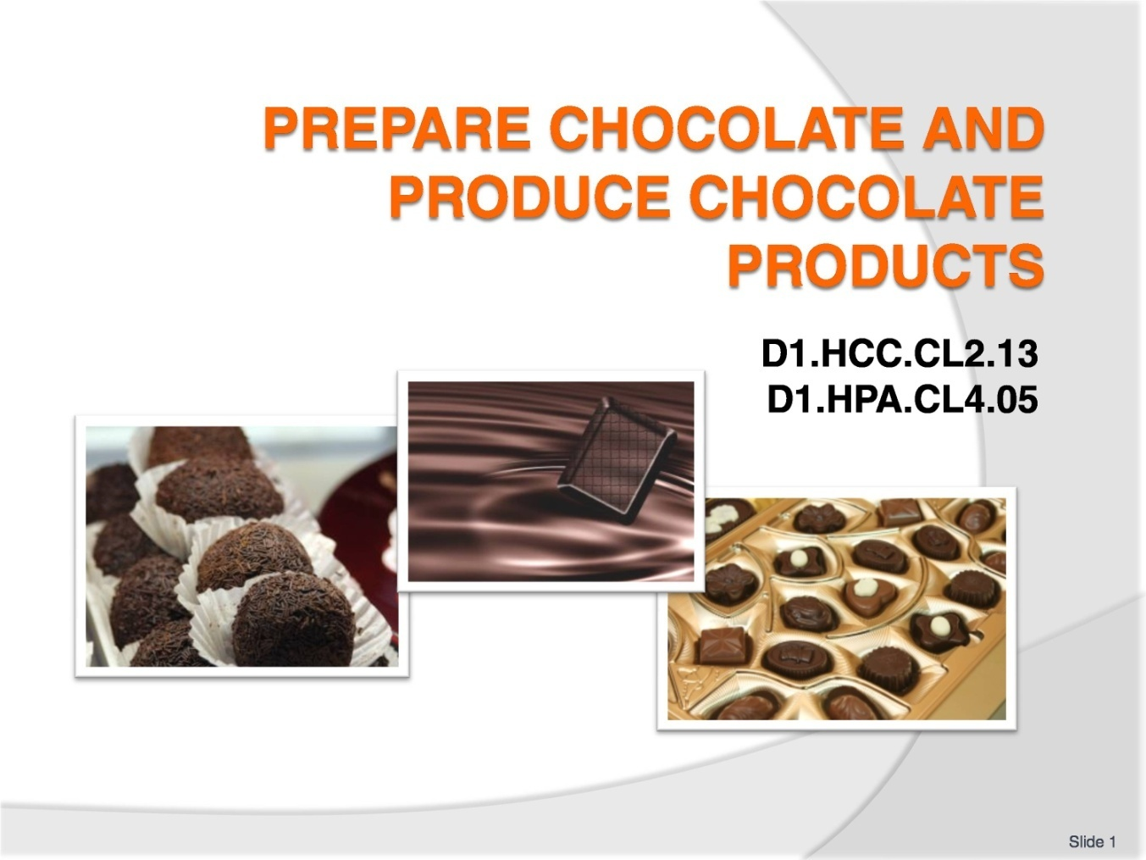
Slide No | Trainer Notes
 | Trainer welcomes trainees to class and informs that they will be learning how to “Prepare chocolate and produce chocolate products”.

Slide
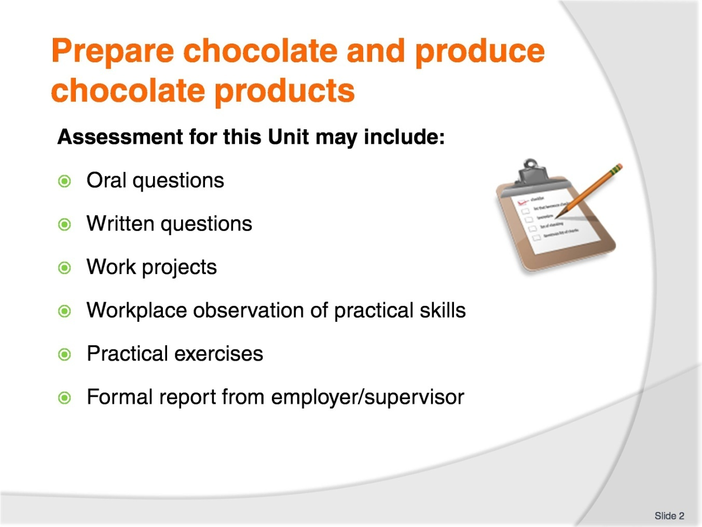
Slide No | Trainer Notes
Trainer advises students that assessment for this Unit may take several forms all of which are aimed at verifying they have achieved competency for the Unit as required.
Trainer indicates to students the methods of assessment that will be applied to them for this Unit.

Slide
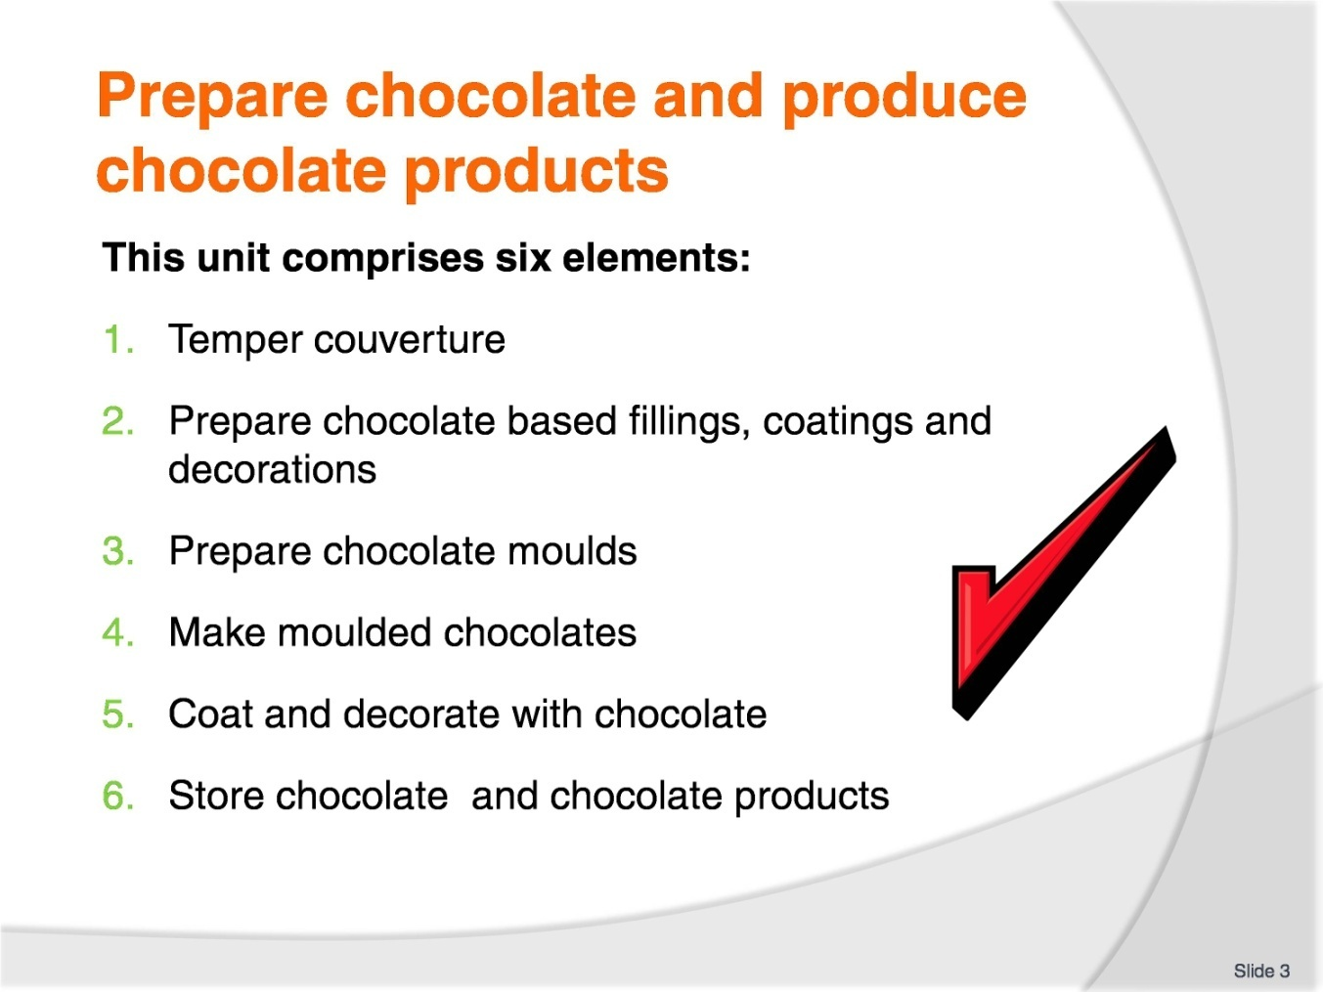
Slide No | Trainer Notes
Trainer advises students this Unit comprises six elements, as listed on the slide explaining:
Each Element comprises a number of Performance Criteria which will be identified throughout the class and explained in detail
Students can obtain more detail from their Trainee Manual
The course presents advice and information but where their workplace requirements differ to what is presented, the workplace practices and standards must be observed.

Slide
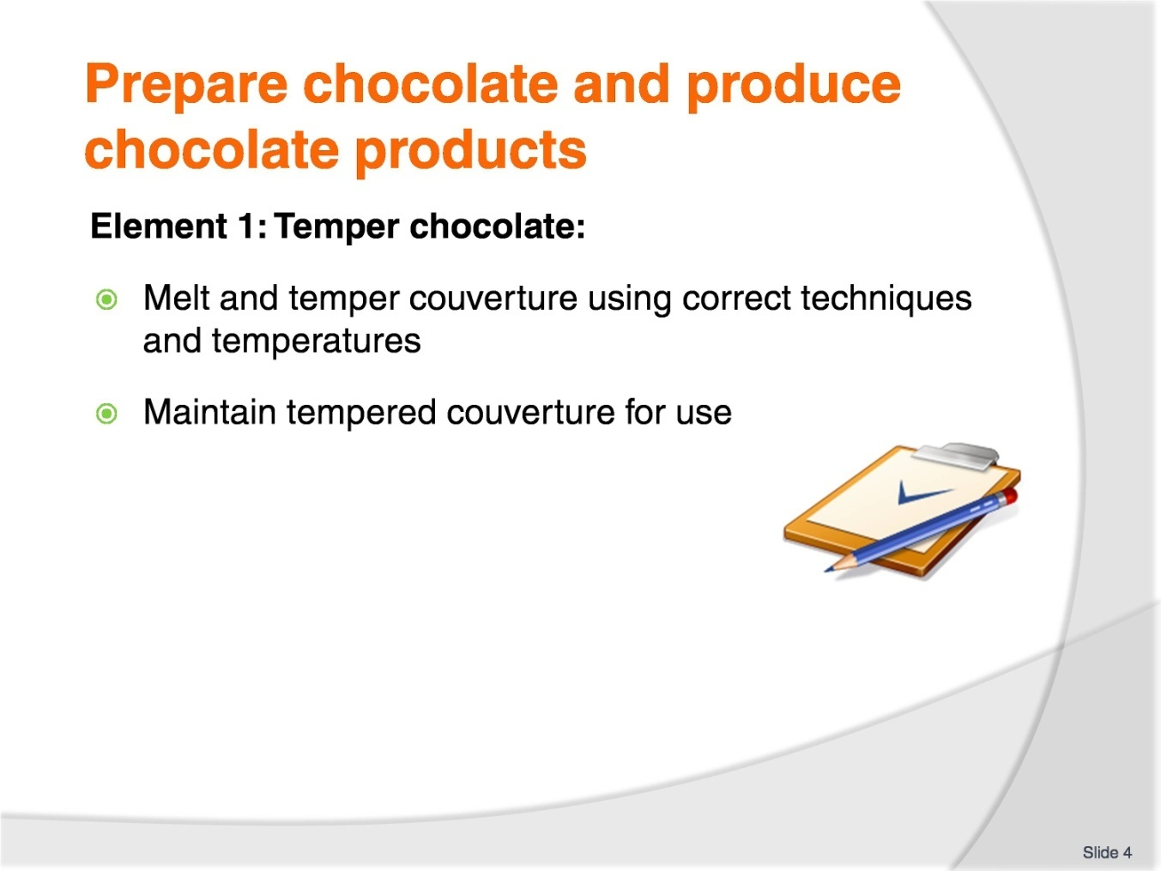
Slide No | Trainer Notes
The trainer to relate how the performance criteria are related to the element 1.
To be able to prepare chocolate and produce chocolate products, the students must be able to temper chocolate.
The student should be able to:
Melt and temper couverture using correct techniques and temperatures
Maintain tempered couverture for use.

Slide
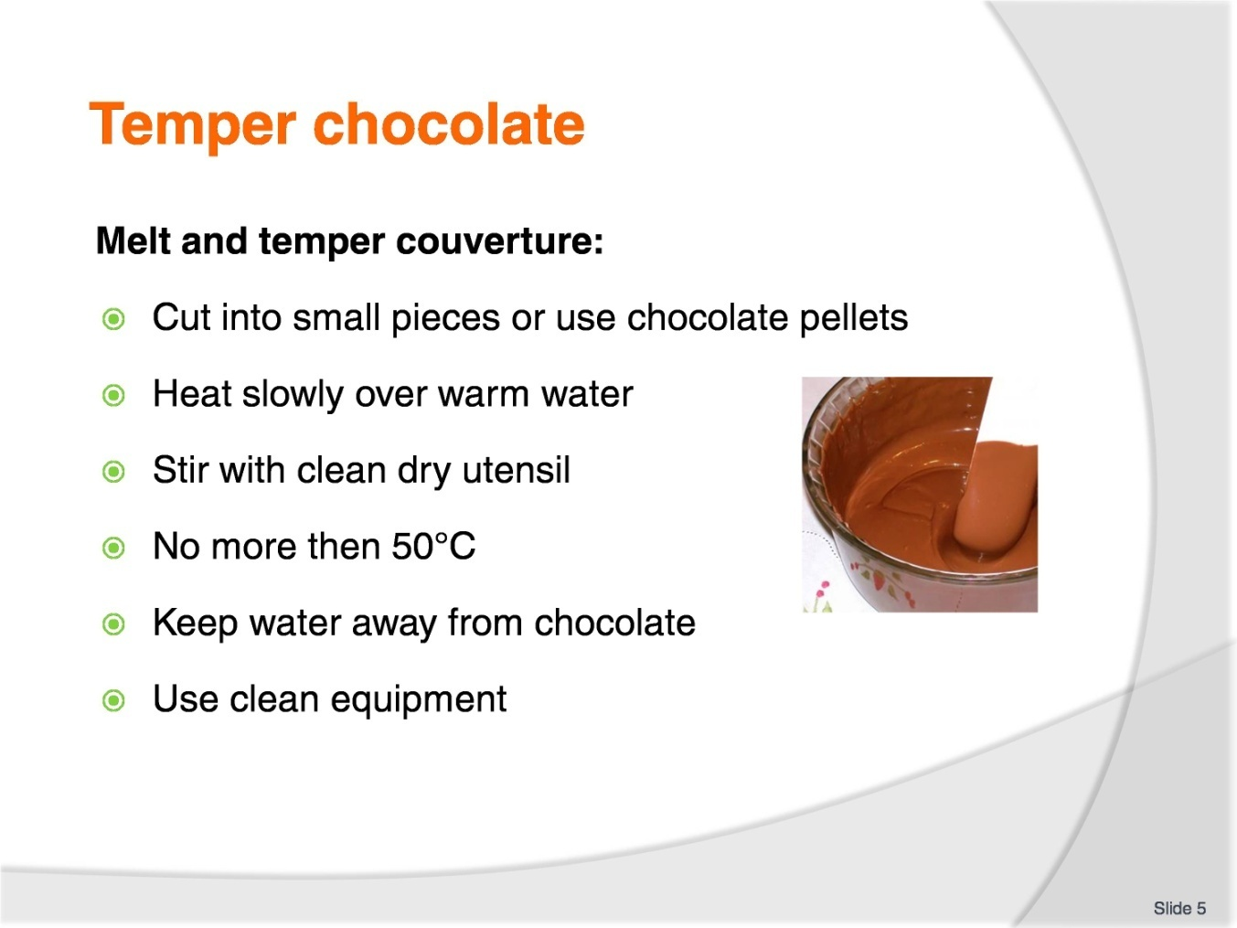
Slide No | Trainer Notes
Trainer to advise:
Cut into small pieces
The faster the chocolate melts the better
Small pieces will melt quicker than larger pieces
Place chocolate into clean DRY container
Allow steam to warm the container that holds the chocolate: DO NOT allow water to touch the container.

Slide
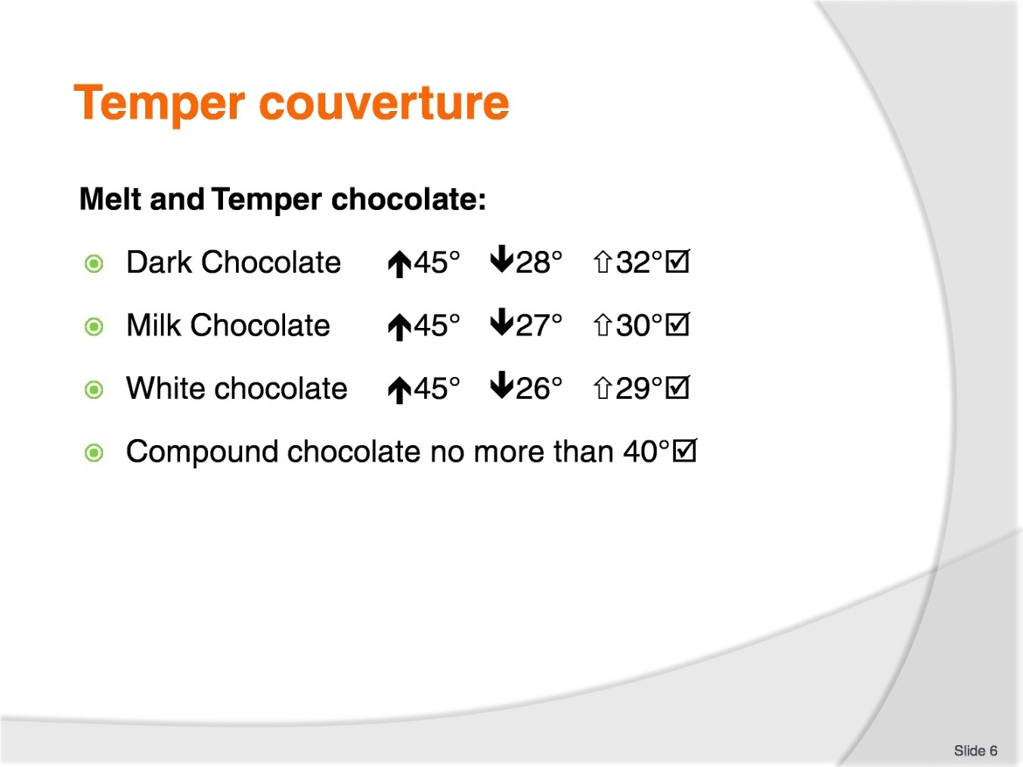
Slide No | Trainer Notes
Trainer to advise:
Temperature range to be measured when tempering chocolate
Use digital thermometer
Stir slowly.

Slide
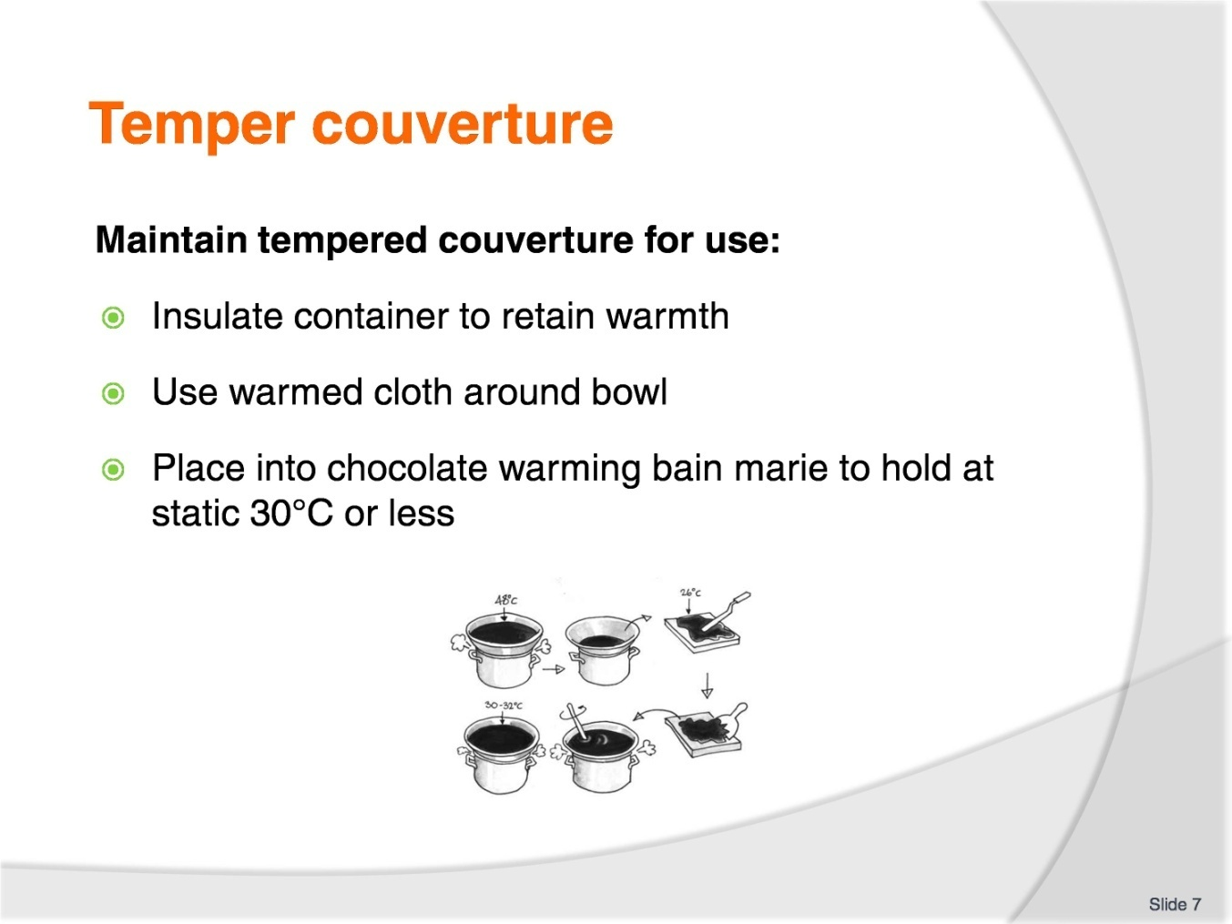
Slide No | Trainer Notes
Trainer to advise:
Working in colder climates like Europe and Southern Australia, air temperature can be as low as 15ºC to 18ºC in workplaces.
It is important to keep the tempered chocolate at a working temperature of 28ºC to 30ºC.
Static warmers: these are basically warm bain-maries using dry electric elements inside a box to keep temperature at a constant temperature.
These are available in various sizes: Contact specialist chocolate supplier.
There are now machines that will temper for the confectioner but these take longer time than what can be achieved by hand.

Slide
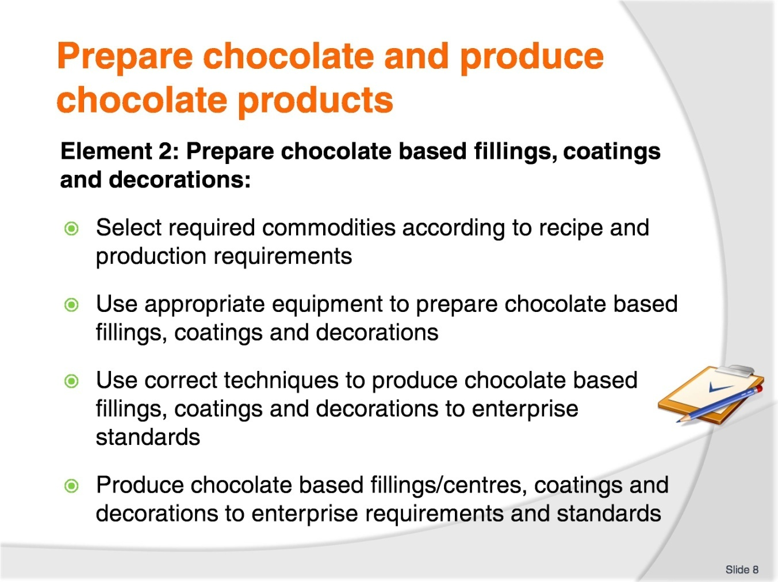
Slide No | Trainer Notes
The trainer to relate how the performance criteria are related to element 2.
To be able to prepare chocolate and produce chocolate products, the students must be able to prepare chocolate based fillings, coatings and decorations.
The student should be able to:
Select required commodities according to recipe and production requirements
Use appropriate equipment to prepare chocolate based fillings, coatings and decorations
Use correct techniques to produce chocolate based fillings, coatings and decorations to enterprise standards
Produce chocolate based fillings/centres, coatings and decorations to enterprise requirements and standards.

Slide
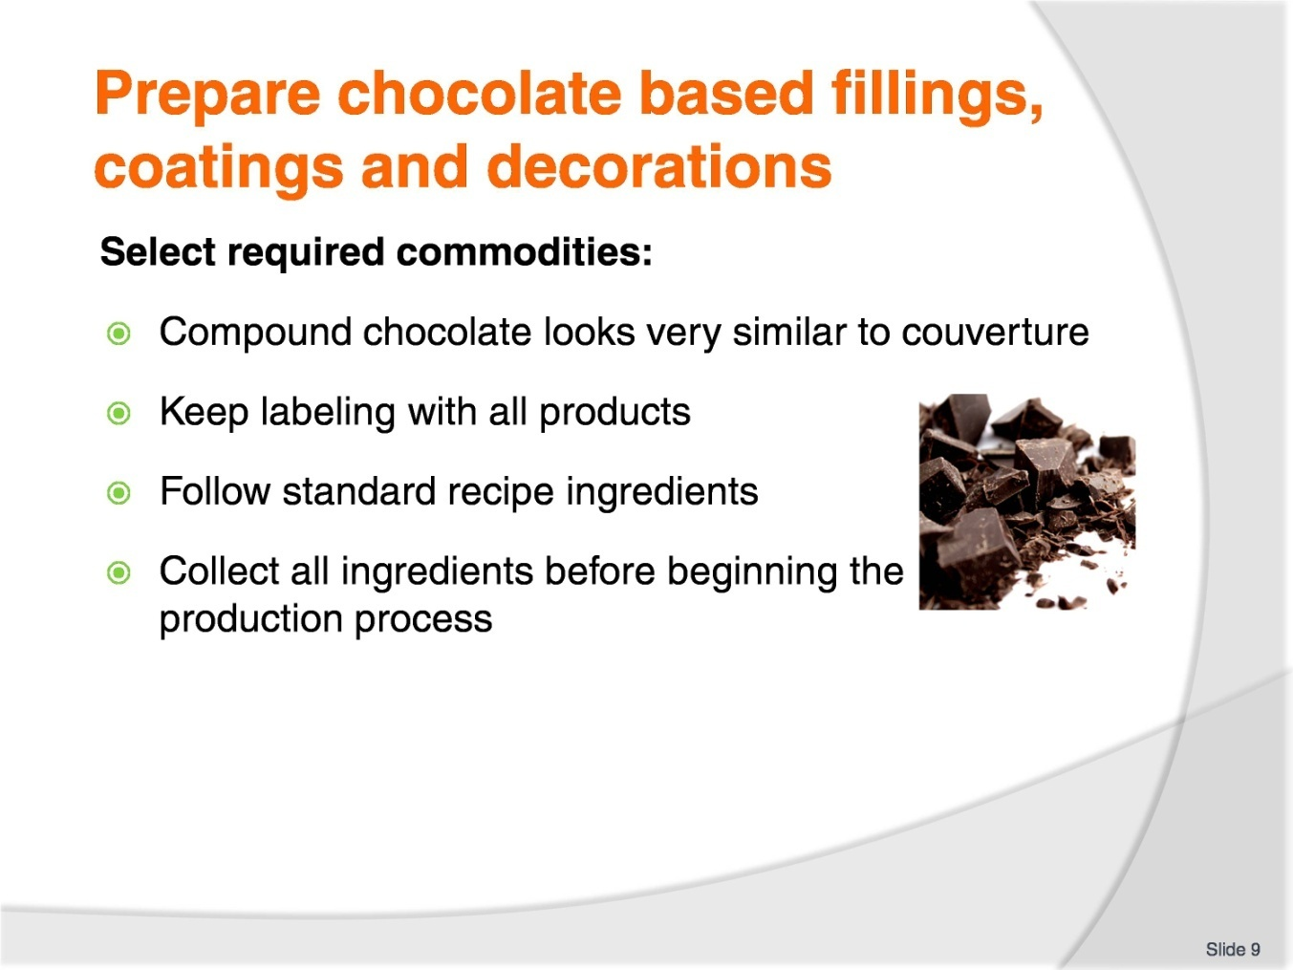
Slide No | Trainer Notes
Trainer to advise:
Confectioners need to be able to identify quality products
Compound chocolates are similar to couverture
Remember: couverture is the better product with excellent mouth feel and longer flavour structures in the mouth after consumption
All products must have a standard recipe; this keeps the consistency in the product
The customers want the same product as they purchased last time.

Slide
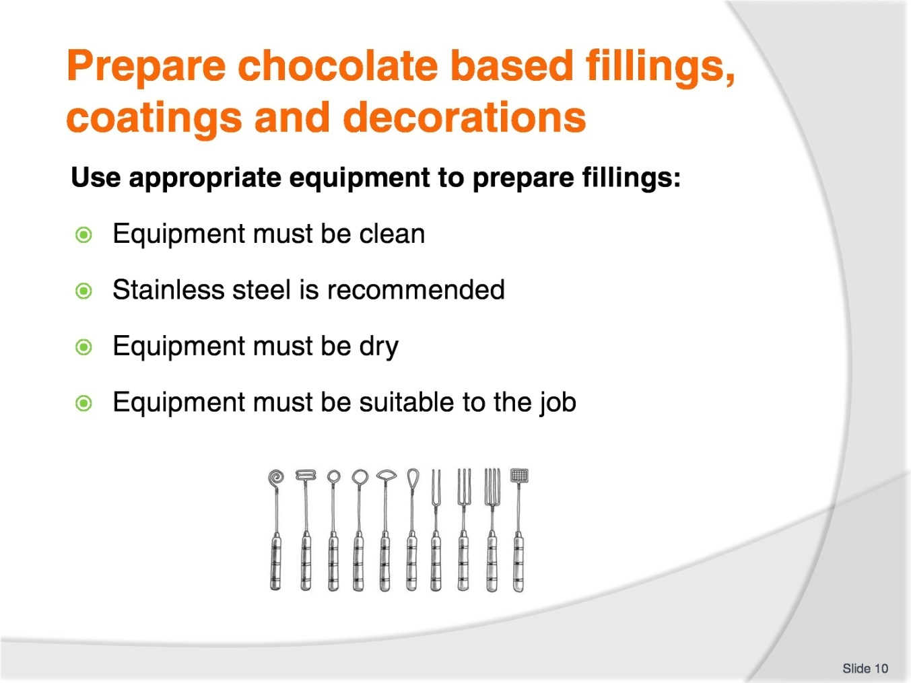
Slide No | Trainer Notes
Trainer to advise:
Even the small equipment must be suitable for the job.
Example:
Do not try to stir the chocolate with a small spoon
Use a good size spoon that is clean
It must not be a spoon that has been used to stir savoury foods and is embedded with taste of garlic and onions for example.

Slide
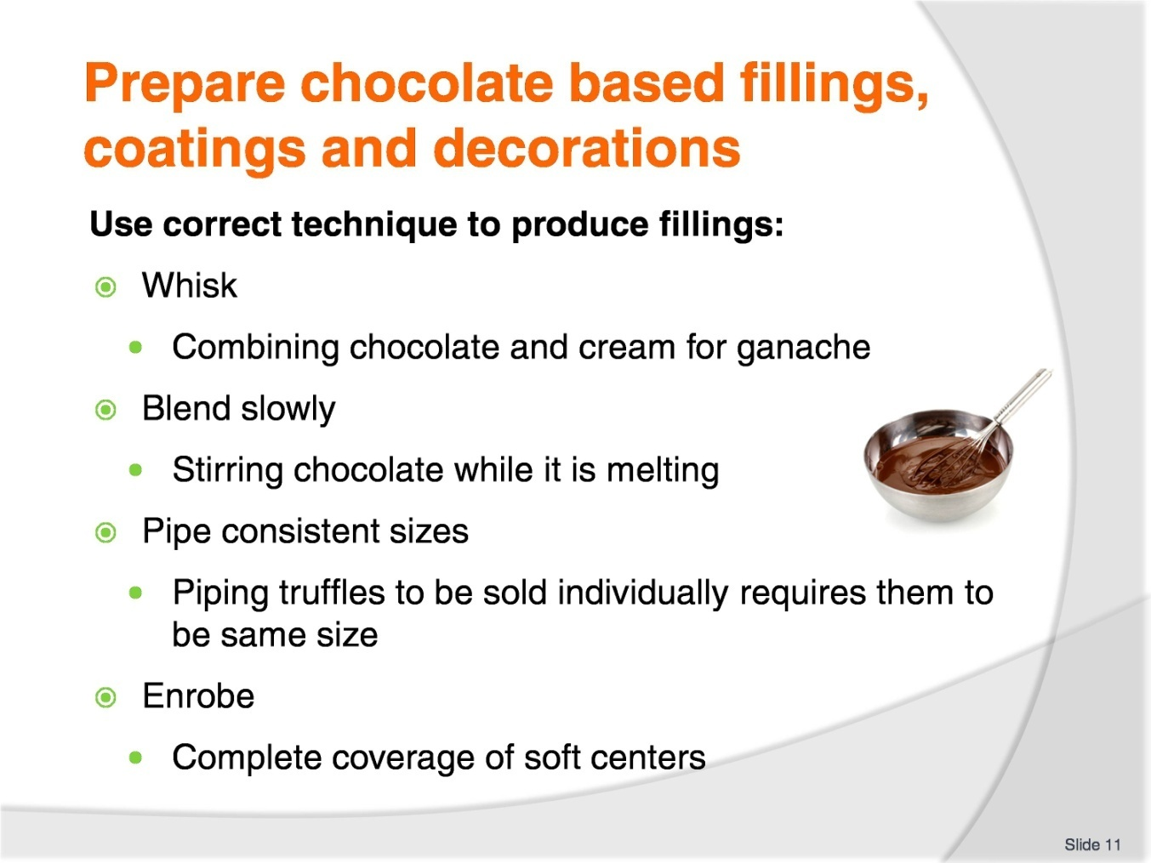
Slide No | Trainer Notes
Trainer to advise:
The skills used by the confectioner is the same as the patissier:
Blend
Whisk
Enrobe
Piping.
Many skills are required but the most important is ‘patience’.
All steps must be followed.
If shortcuts are used then product quality will be compromised.

Slide
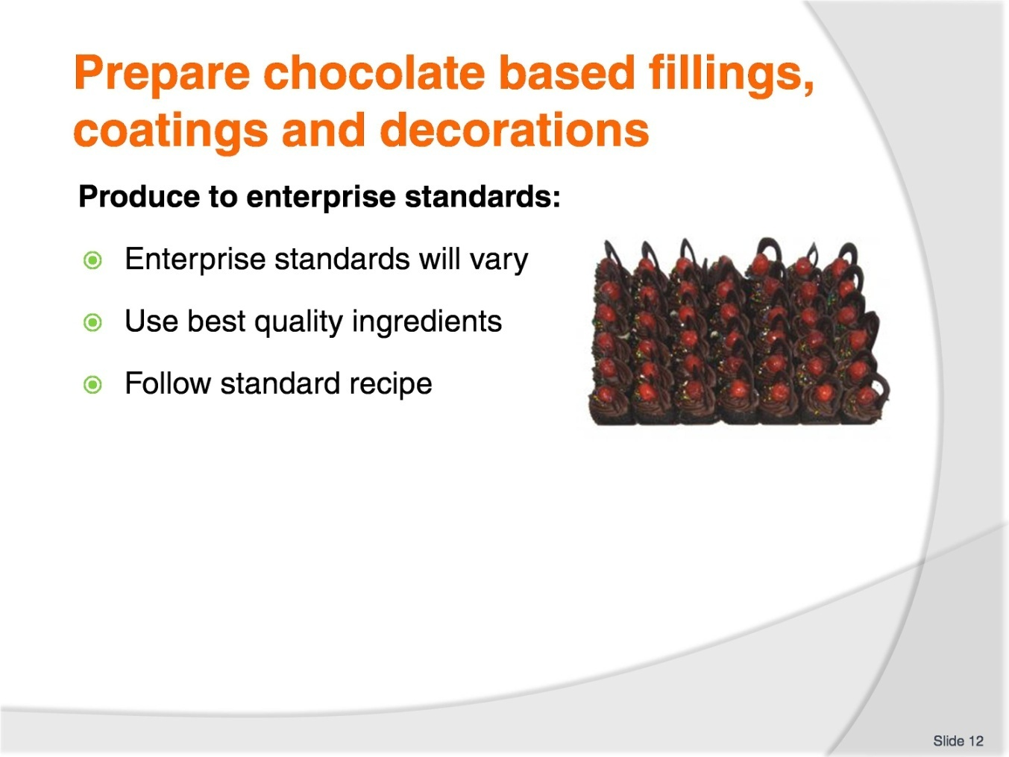
Slide No | Trainer Notes
Trainer to advise:
Enterprises will have varying standards
What is the market place that is being supplied
High quality; the best ingredients and flavourings
Budget quality; good quality ingredients.

Slide
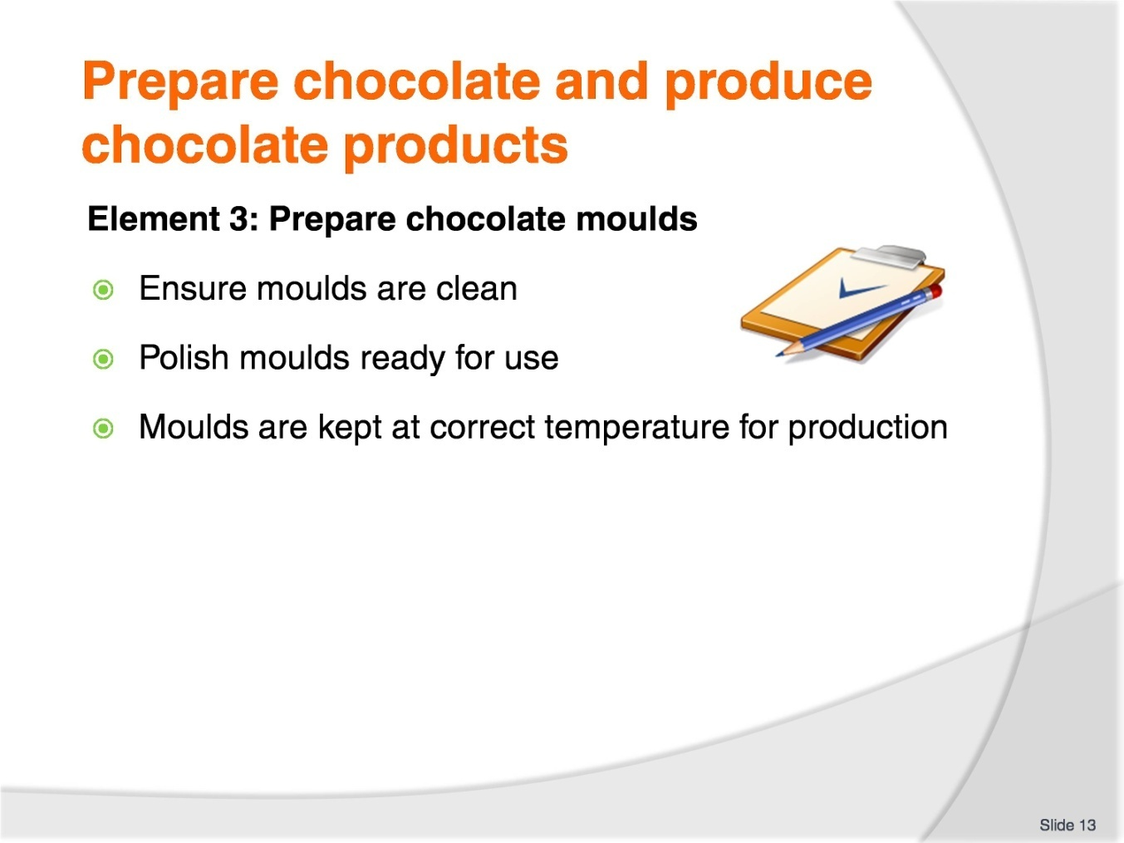
Slide No | Trainer Notes
The trainer to relate how the performance criteria are related to the element 3.
To be able to prepare chocolate and produce chocolate products, the students must be able to prepare chocolate moulds.
The student should be able to:
Ensure moulds are clean
Polish moulds ready for use
Keep Moulds at correct temperature for production.

Slide
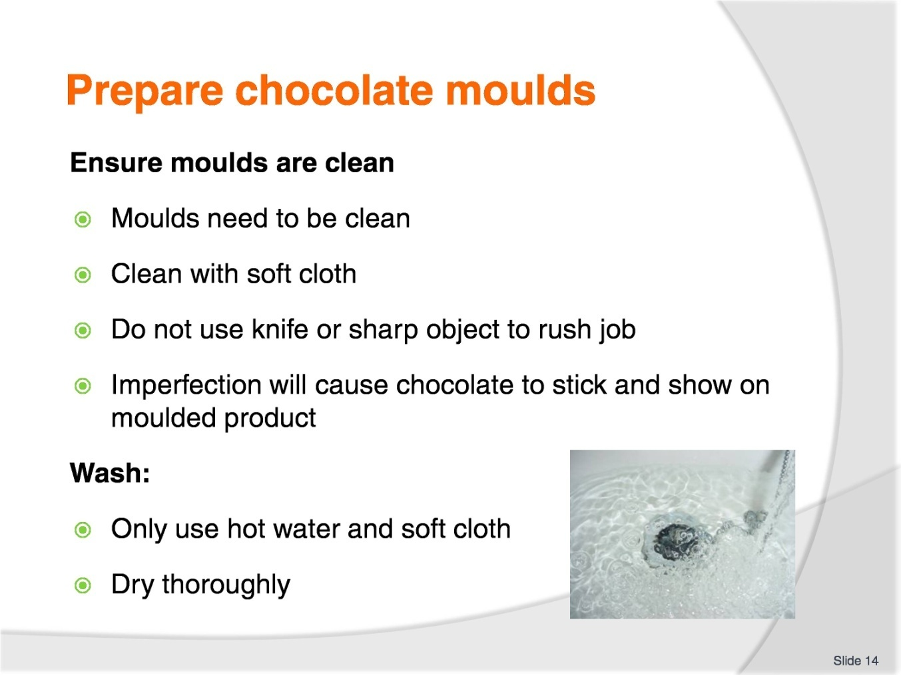
Slide No | Trainer Notes
Trainer to advise:
Any imperfection on inside of mould will show as an imperfection on moulded chocolate when it is demoulded
Do not scrape or scratch cold chocolate from mould
Wash in hot water and mild detergent; rinse in hot water
Use soft cloth to wipe chocolate from mould
Air dry
Use hair dryer if required.

Slide
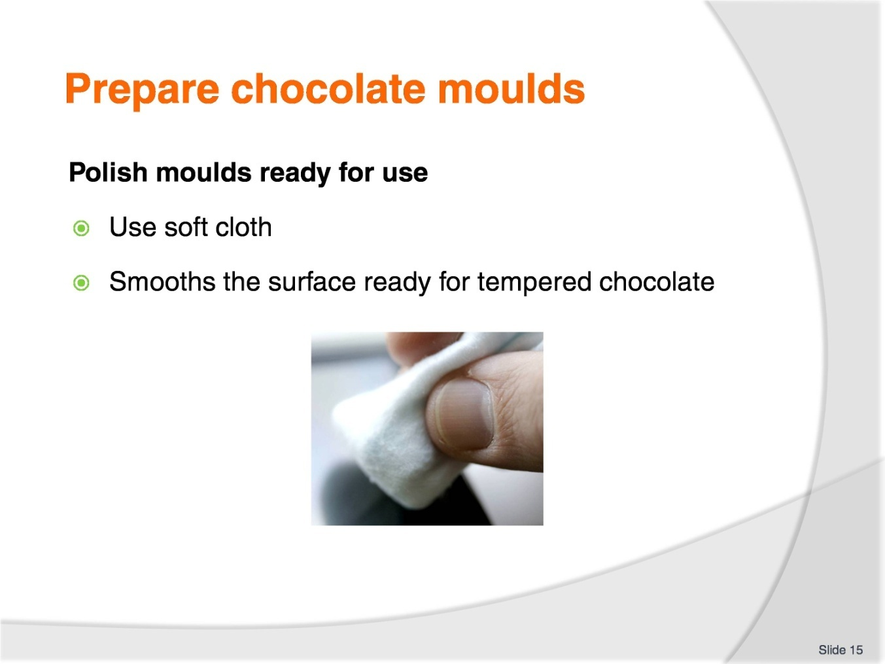
Slide No | Trainer Notes
Trainer to advise:
Polish with clean soft cloth
If surface is clean the chocolate will release from the surface when it contracts
The product will then release from mould more easily.

Slide
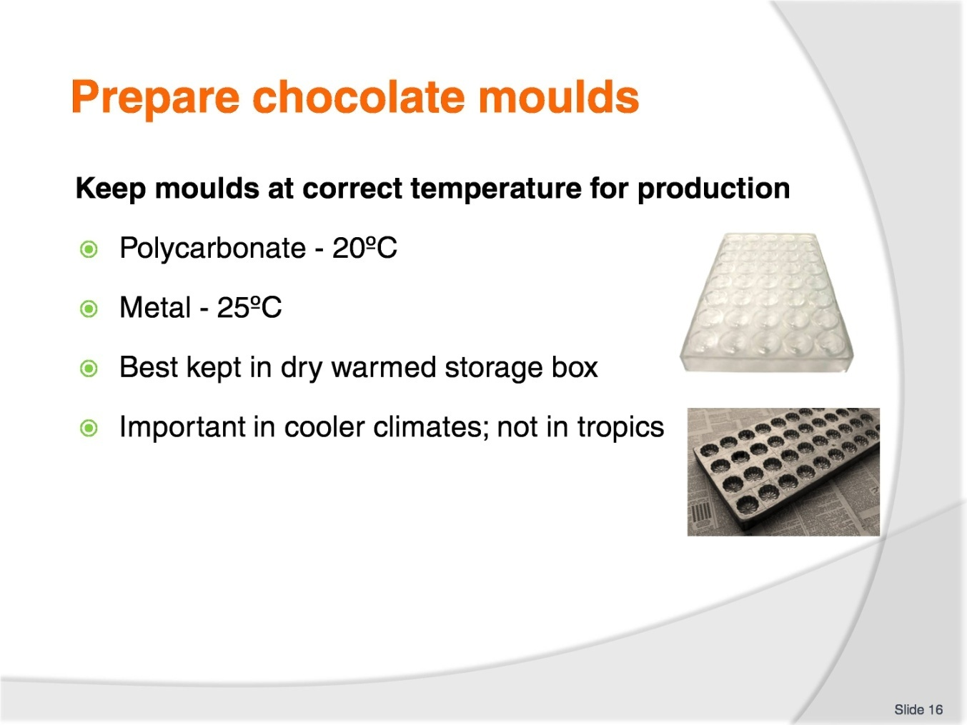
Slide No | Trainer Notes
Trainer to advise:
If the moulds are too cold the chocolate will thicken too quickly
Especially when doing filled chocolates and when tipped over the shell will be too thick and not be able to hold enough filling
Keep moulds in secure storage to will minimise chance of damage.

Slide
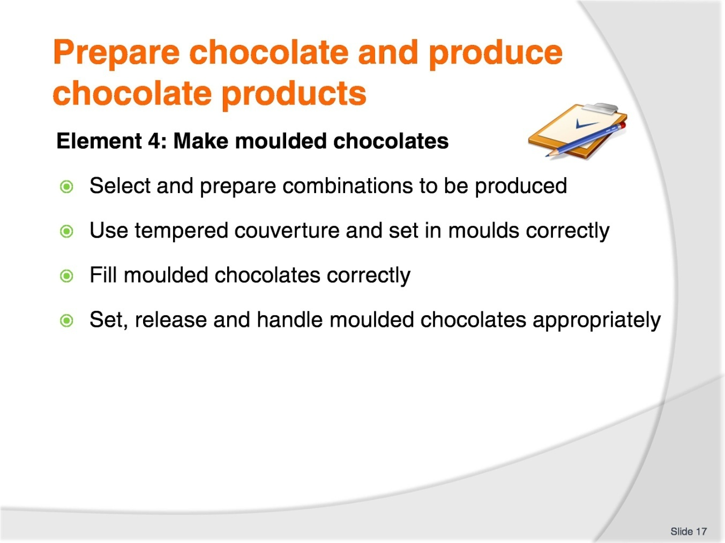
Slide No | Trainer Notes
The trainer to relate how the performance criteria are related to the element 4.
To be able to prepare chocolate and produce chocolate products, the students must be able to make moulded chocolates.
The student should be able to:
Select and prepare combinations to be produced
Use tempered couverture and set in moulds correctly
Fill moulded chocolates correctly
Set, release and handle moulded chocolates appropriately.

Slide
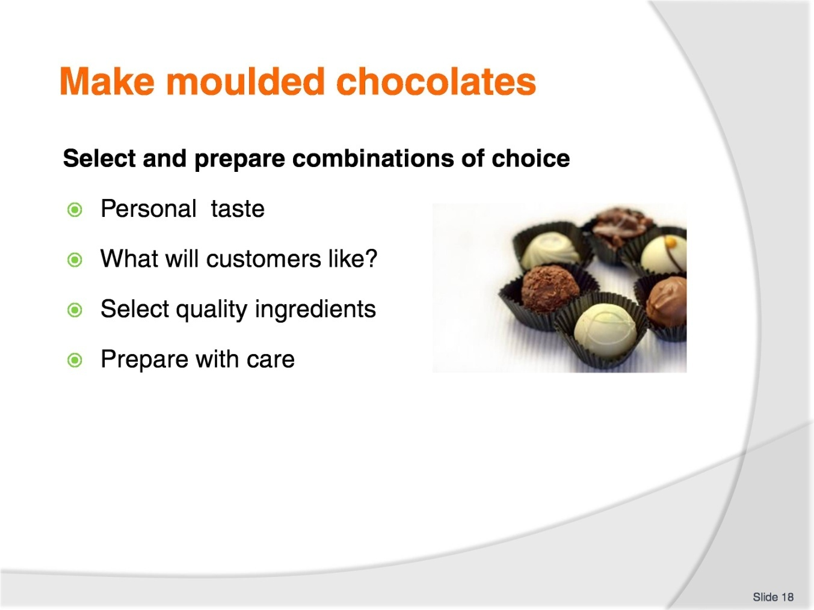
Slide No | Trainer Notes
Trainer to advise:
Confectioners need to produce product that will sell
Use combinations that are known to work and have been sold before
Be adventurous with some flavour combinations
Chilli chocolate was not used 30 years ago but is now popular in Australia
Not a big market BUT the flavour combination is enjoyed by some people.
Student Activity
Ask the students to work on flavour combinations
Who has eaten chilli chocolate?

Slide
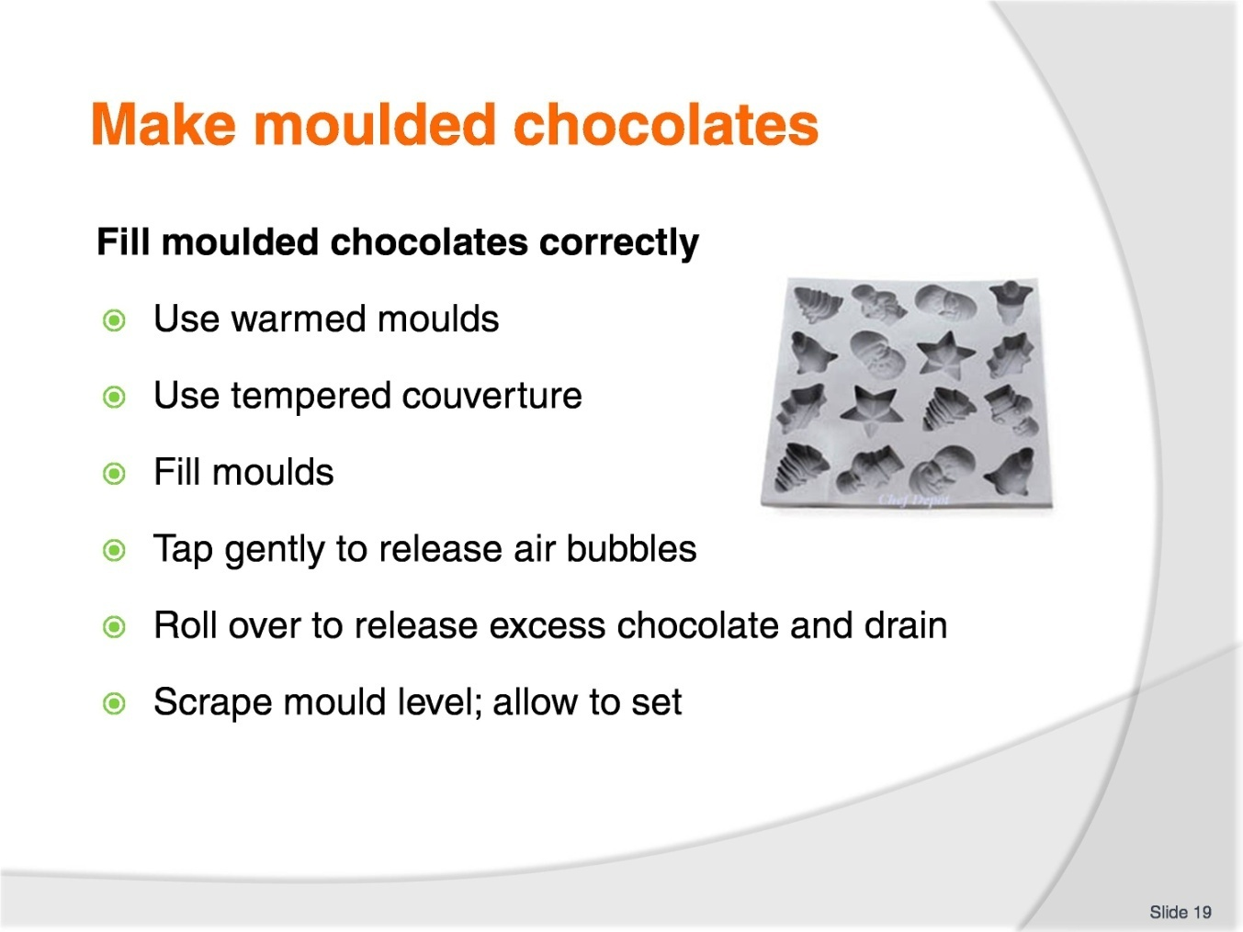
Slide No | Trainer Notes
Trainer to advise:
With properly prepared moulds and correctly tempered couverture:
Fill moulds with couverture
Tap mould gently on bench to all any air bubbles to move away from edges of moulds
Tip moulds over to allow excess couverture to drain out
When majority of couverture has drained, turn mould back upright
Scrape with PLASTIC scraper the base of moulded shell to give straight edge to chocolate base.

Slide
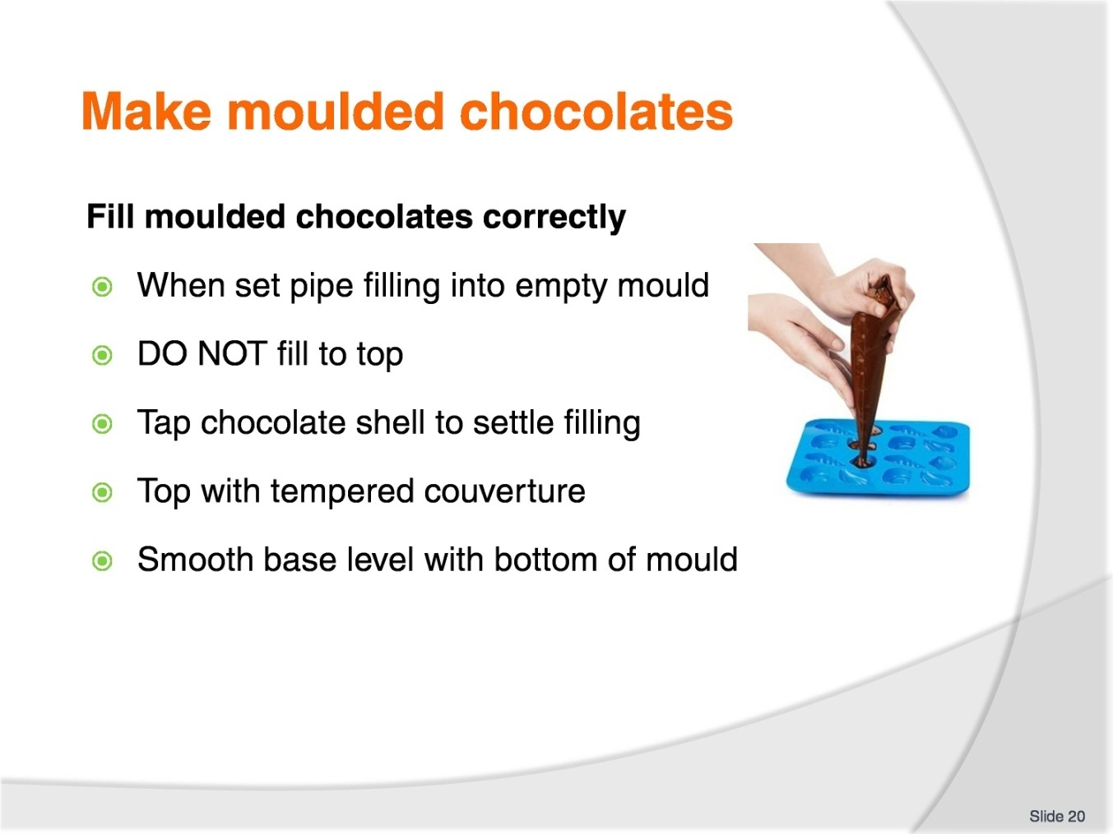
Slide No | Trainer Notes
Trainer to advise:
Filling of empty chocolate shell requires a fine tipped piping bag:
Do not fill the moulded chocolate
This is biggest mistake of beginners
Leave space for the remaining couverture base
The filling must be below the surface of the edge of the mould.
Pour couverture over the base
Smooth with flat plastic scraper to remove all excess chocolate from base.

Slide
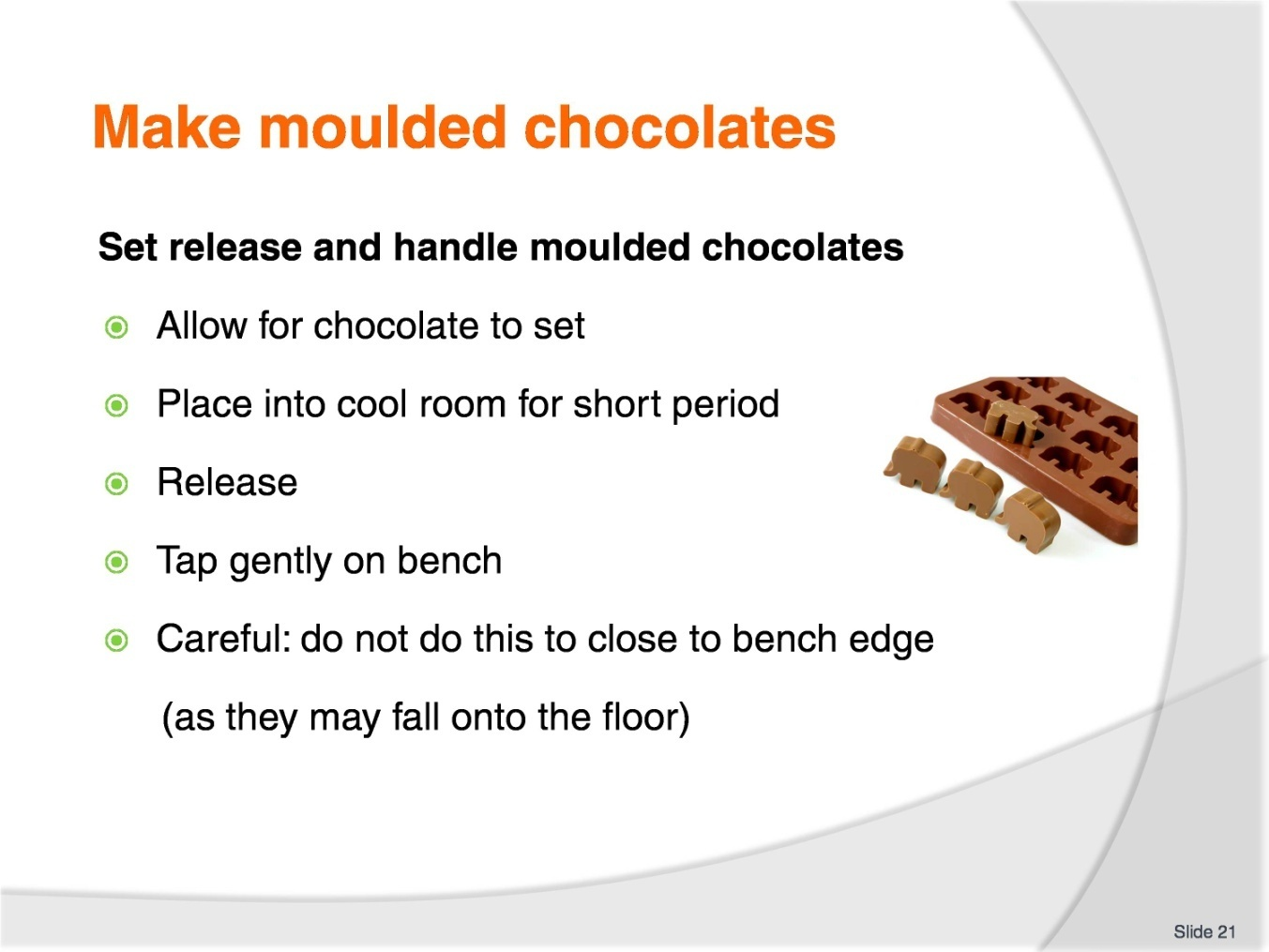
Slide No | Trainer Notes
Trainer to advise:
Set aside in cool space for chocolate to set and harden
In warmer climates chocolate may need to be placed into cool room for short period to set chocolate
When set , invert mould over papered bench and tap sharply on bench top to dislodge product from mould
Using a gloved hand place chocolate onto clean tray; place into covered storage space.

Slide
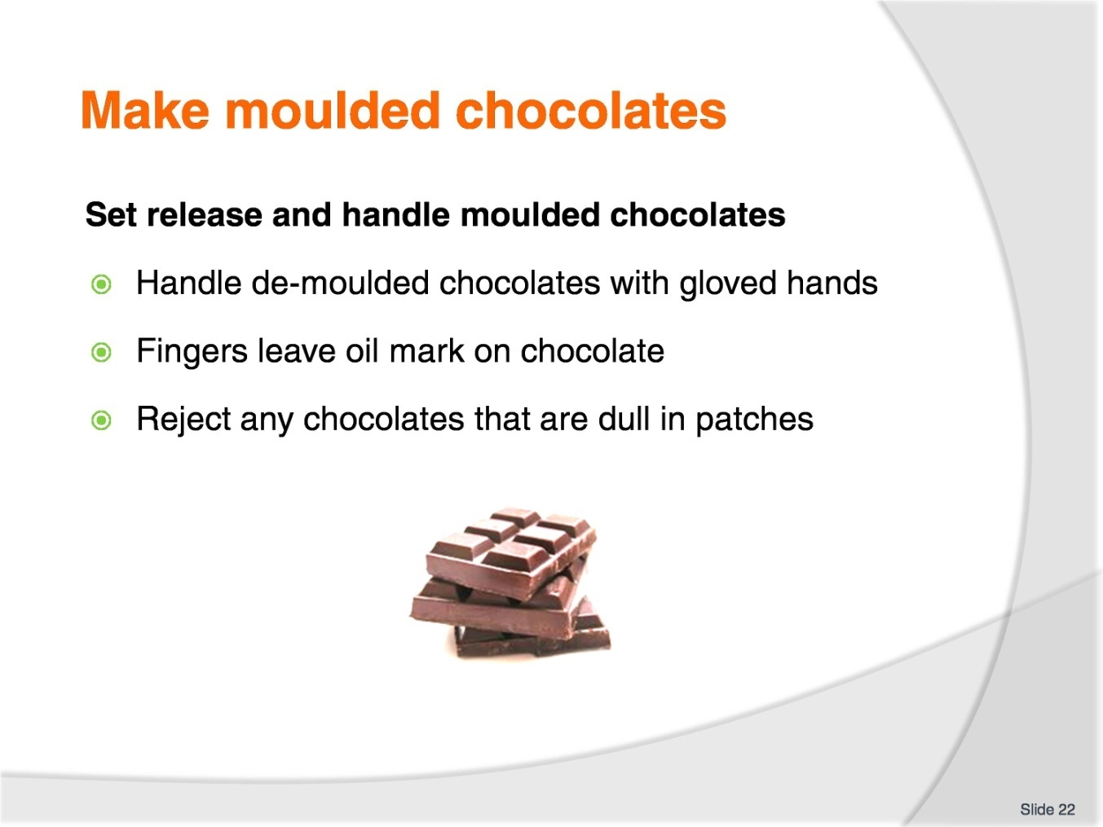
Slide No | Trainer Notes
Trainer to advise:
When set , invert mould over papered bench and tap sharply on bench top to dislodge product from mould
Using a gloved hand place chocolate onto clean tray; place into covered storage space
Any chocolates that show blemishes should be set aside and recycled.

Slide
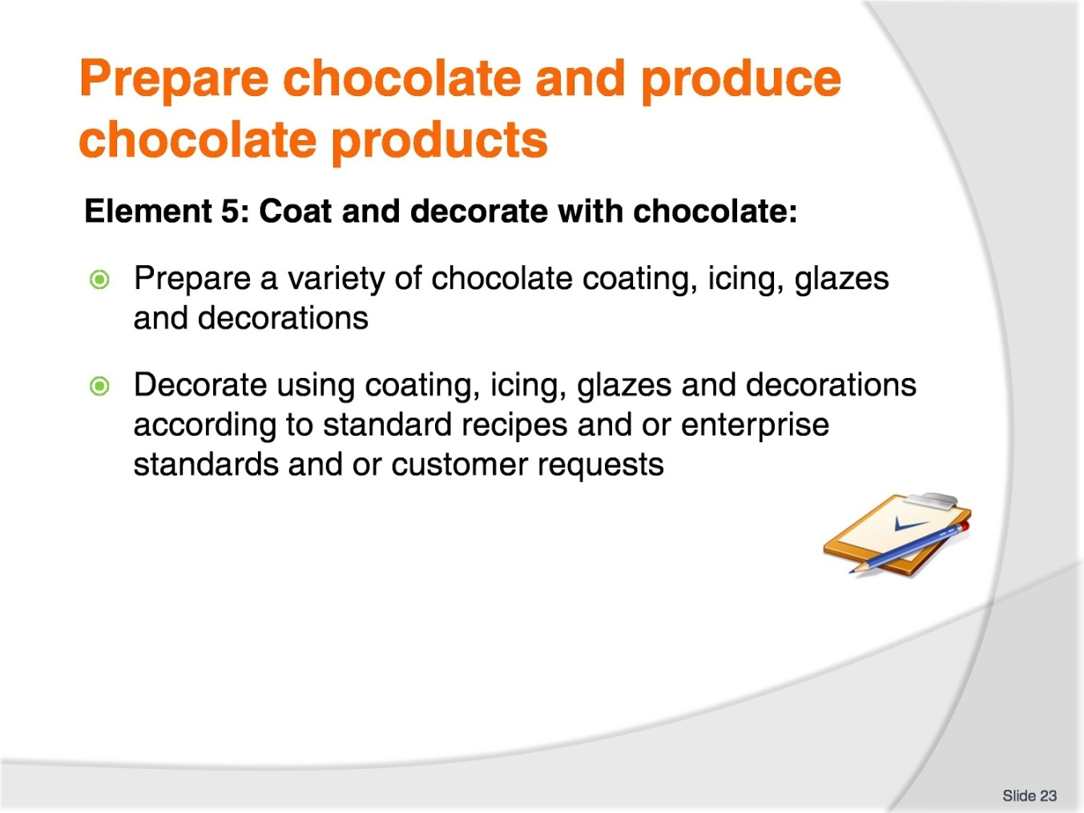
Slide No | Trainer Notes
The trainer to relate how the performance criteria are related to the element 5.
To be able to prepare chocolate and produce chocolate products, the students must be able to coat and decorate chocolates.
The student should be able to:
Prepare a variety of chocolate coating, icing, glazes and decorations
Decorate using coating, icing, glazes and decorations according to standard recipes and/or enterprise standards and/or customer requests.

Slide
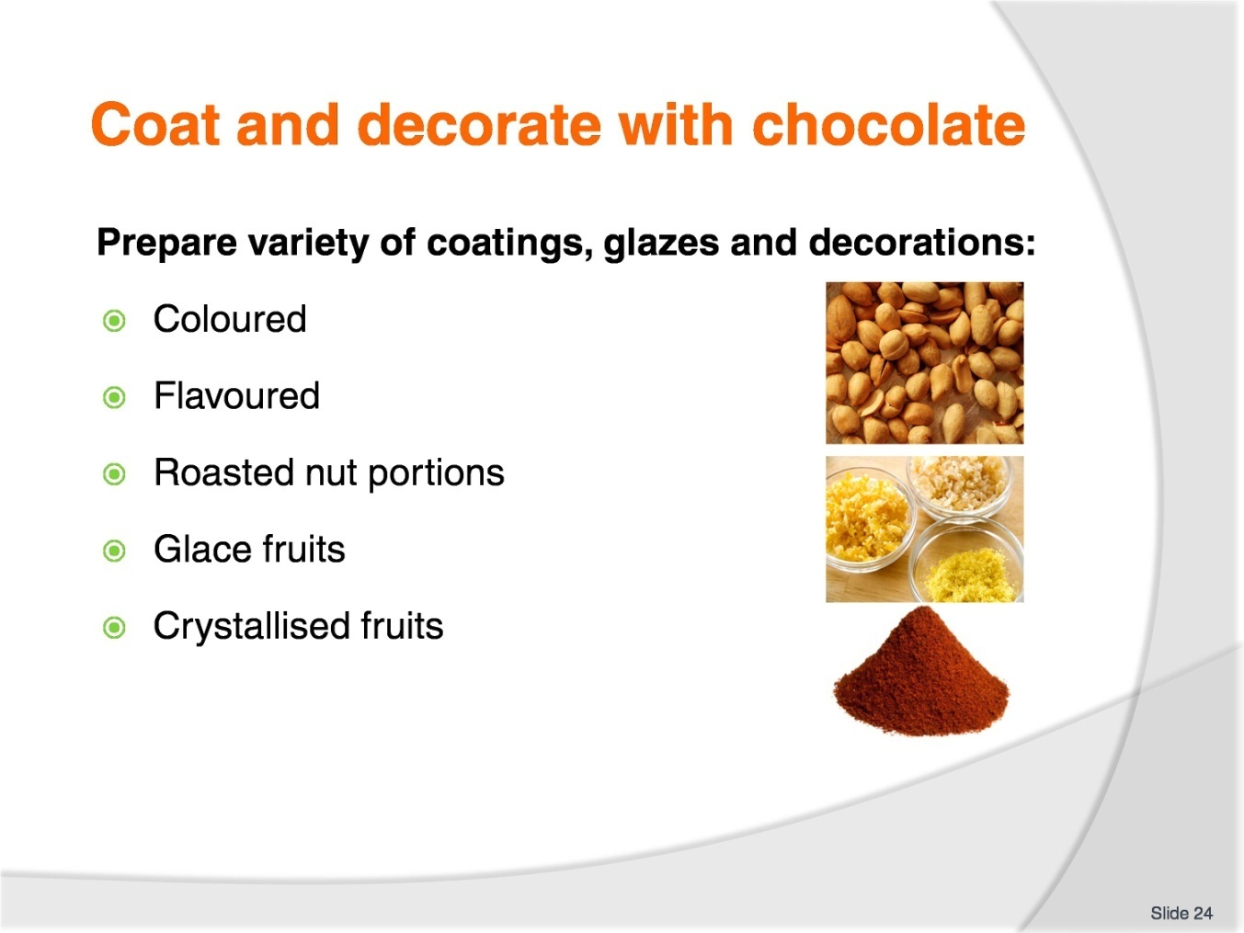
Slide No | Trainer Notes
Trainer to advise:
Many variations exist for decorating finished chocolates.
Basic rules:
Decoration must be edible
Decorations must be long lasting and not be affected by air dehydration; examples to use are glace fruits, nut portions, crystallised fruits
Decorations must not lose appearance by being exposed to air.

Slide
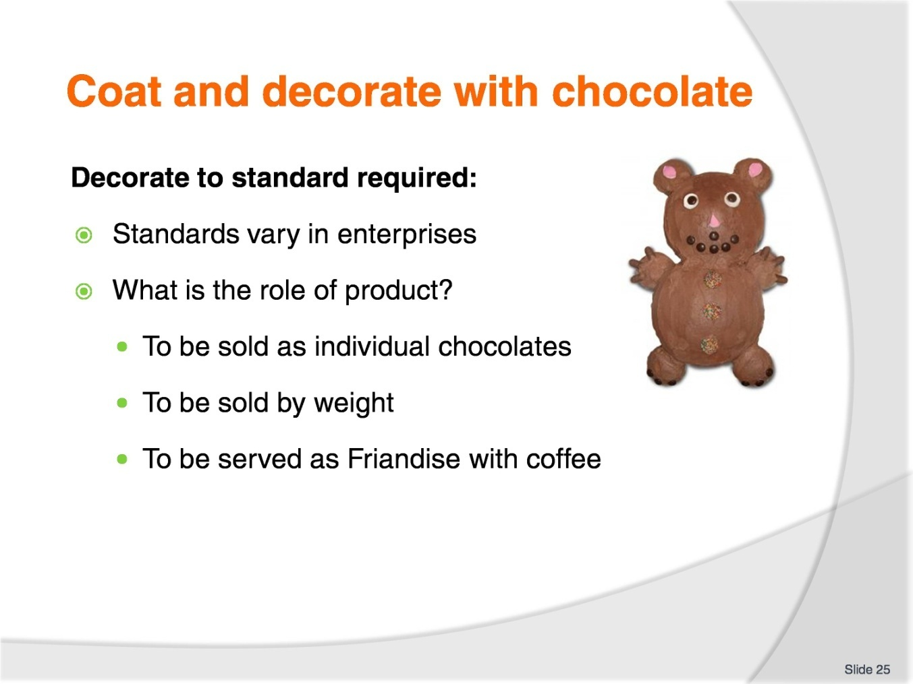
Slide No | Trainer Notes
Trainer to advise:
Chocolates standard will vary due to the role that they will be required
If they are sold individually then they must all look the same
Sold by weight (by the kilo) then they may be slightly different in size
Maybe they are to be used as friandise with coffee
Decoration will vary but should always compliment the flavour.

Slide
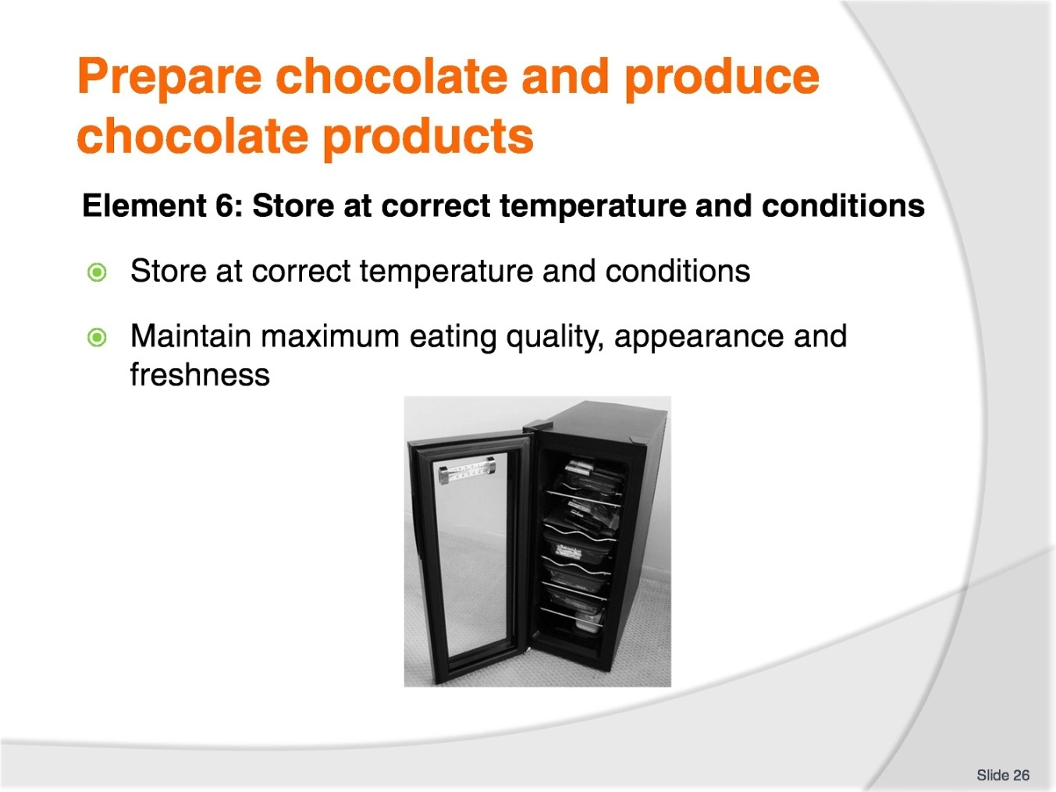
Slide No | Trainer Notes
Trainer to advise:
The trainer to relate how the performance criteria are related to the element 6.
To be able to prepare chocolate and produce chocolate products, the students must be able to store chocolate at correct temperature and conditions.
The student should be able to:
Store at correct temperature and conditions
Maintain maximum eating quality, appearance and freshness.

Slide
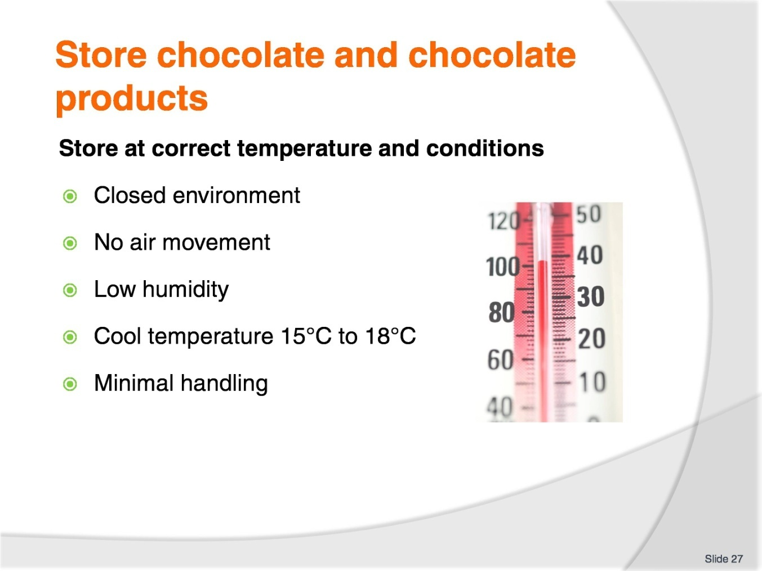
Slide No | Trainer Notes
Trainer to advise:
Chocolate products are susceptible to damage easily
They are a delicate product
If humidity is too high water condensation will appear on surface and cause chocolate to go grey
Keep covered
Keep cool
Low humidity environment
Less than 50% is preferred.

Slide
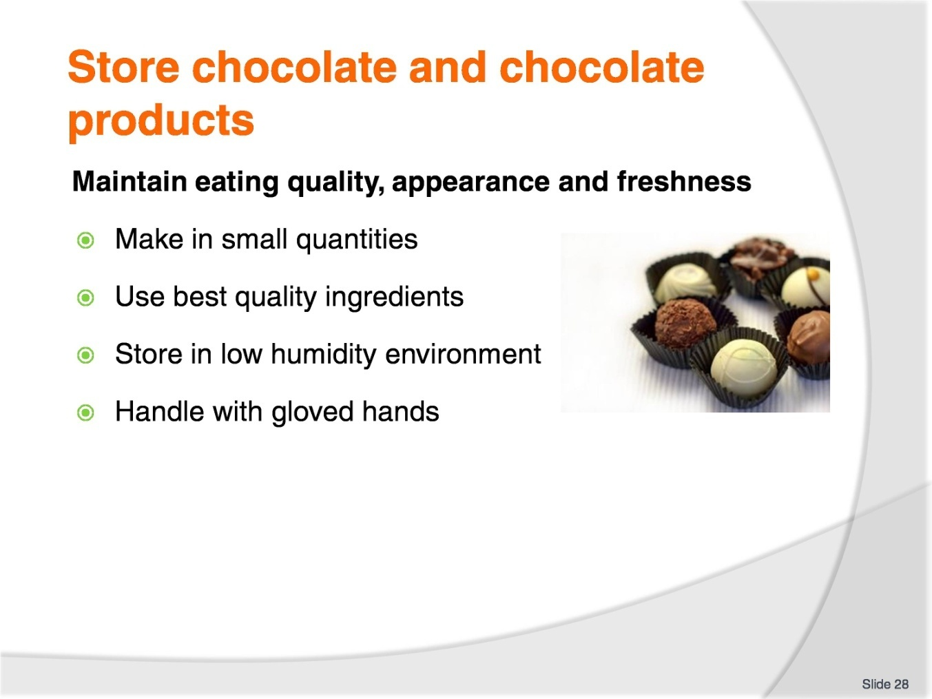
Slide No | Trainer Notes
Trainer to advise:
Best way to maintain eating quality is to use best quality ingredients and to make in small batches
Make often
Appearance: to keep their gloss chocolates must be stored in low humidity environment
Handling; handle with gloved hands as oil in skin leaves residue mark in gloss on chocolates.

Recommended training equipment
Work benches of stainless steel preferred
Stainless steel sinks for washing
Stove for cooking as required
Stainless steel bowls of various sizes
Palette knives
Plastic scrapers
Piping bags, clean disposable are recommended
Piping tubes of various sizes
Polycarbonate chocolate moulds; of sizes and shapes desired
Cooking pots
Warming cupboards for mould storage
Spoons for stirring chocolate
Whisks
Steel scrapers for handling chocolate
Ingredients
Couverture
Other ingredients as required by standard recipe
Flavourings as required from standard recipes
Generic kitchen supplies
Plastic wrap
Baking paper
Detergent for cleaning
General cleaning supplies

Instructions for Trainers for using
PowerPoint – Presenter View
Connect your laptop or computer to your projector equipment as per manufacturers’ instructions.
In PowerPoint, on the Slide Show menu, click Set up Show.
Under Multiple monitors, select the Show Presenter View check box.
In the Display slide show on list, click the monitor you want the slide show presentation to appear on.
Source: http://office.microsoft.com
Note:
In Presenter View:
You see your notes and have full control of the presentation
Your trainees only see the slide projected on to the screen
More Information
You can obtain more information on how to use PowerPoint from the Microsoft Online Help Centre, available at: http://office.microsoft.com/training/training.aspx?AssetID=RC011298761033
Note Regarding Currency of URLs
Please note that where references have been made to URLs in these training resources trainers will need to verify that the resource or document referred to is still current on the internet. Trainers should endeavour, where possible, to source similar alternative examples of material where it is found that either the website or the document in question is no longer available online.

Appendix – ASEAN acronyms
AADCP | ASEAN – Australia Development Cooperation Program.
ACCSTP | ASEAN Common Competency Standards for Tourism Professionals.
AEC | ASEAN Economic Community.
AMS | ASEAN Member States.
ASEAN | Association of Southeast Asian Nations.
ASEC | ASEAN Secretariat.
ATM | ASEAN Tourism Ministers.
ATPMC | ASEAN Tourism Professionals Monitoring Committee.
ATPRS | ASEAN Tourism Professional Registration System.
ATFTMD | ASEAN Task Force on Tourism Manpower Development.
CATC | Common ASEAN Tourism Curriculum.
MRA | Mutual Recognition Arrangement.
MTCO | Mekong Tourism Coordinating office.
NTO | National Tourism Organisation.
NTPB | National Tourism Professional Board.
RQFSRS | Regional Qualifications Framework and Skills Recognition System.
TPCB | Tourism Professional Certification Board.







